Gabapentinoid Reduction – Patient Information Leaflet

This information leaflet is designed to inform patients about the process of reducing their dosage of gabapentin or pregabalin.

It has been reproduced and shared with the kind permission of the authors, NHS Fife.

NHS Scotland Health Boards are free to amend and reproduce as they require. It is the responsibility of Boards to ensure it complies with local policies on accessibility (for example, translations).

Gabapentinoids includes the medications gabapentin and pregabalin

This leaflet applies to gabapentinoid use in chronic pain only

What are gabapentinoids?
Gabapentinoids are medications used to help manage nerve (neuropathic) pain. Neuropathic pain is a type of pain that follows after damage to a nerve. It is thought to result from a “rewiring” of the nerves of the spinal cord .They become very sensitive and send too many pain signals. The pain can be there all the time or can come and go. Normal touch can feel painful. There is often a “burning” or “shooting” feeling, or pins and needles.

Why reduce?
A trial reduction of gabapentinoid should be considered every 6-12 months, when prescribed for chronic pain. A review and trial reduction can be useful to check:
- whether nerve pain is still a problem
- whether you are still getting benefit
- if it is causing any side effects

How to reduce gabapentinoids
The dose should be reduced gradually each week as this will minimise withdrawal effects. It will also allow you to check if there is any change in your pain. The amount and time will depend on your current dose and how long you have been taking the medication. Often the dose can be reduced in reverse order to how it was increased.
- Gabapentin could be reduced by 300mg per week
- Pregabalin could be reduced by 75mg per week

Please follow your reduction plan. Gabapentin and pregabalin come in different strengths. You may require different strengths to allow you to follow the reduction plan.

Do not try to reduce at stressful times or when your pain is flared up. Do not make more than one medication change at the same time.

What are withdrawal symptoms?
Withdrawal symptoms may occur when you have been taking a medication for some time and then stop it suddenly. These can be reduced or stopped from happening by reducing the dose slowly.

The most common withdrawal effects are:
- Anxiety
- Difficulty sleeping
- Nausea
- Pain
- Sweating
These can occur within a day and last up to seven days. If you do get withdrawal effects then do not reduce further. Maintain the dosage that you have reduced to. Wait for the withdrawal effects to stop before reducing further. You may need to reduce more slowly or by smaller amounts to manage these effects.

If withdrawal effects continue to persist then speak to your doctor, pharmacist or pain specialist.

What if my pain increases?
If your pain increases then do not reduce further. Maintain the dosage that you have reduced to.

If the increased pain does not settle within a few weeks then increase your dose slowly again to the lowest dose that controls your pain. This can be done in the reverse order to how it was reduced. This may be less but should not be more than your original dose.

If the increased pain does not settle then speak to your doctor, pharmacist or pain specialist.
Medication in chronic pain
The benefit from taking medication should always be more than any side–effects you may have. Only you
- know how bad your pain is
- are able to say if your medication is helping
- know what side effects you are having

Getting the best effect from your medication may be a matter of trial and error. It may help to keep a diary of your pain and other symptoms. Side effects often become less once you have been on a medicine for a few days. It may be several days or weeks before you notice that a new medicine is making a difference.

Please read the patient information sheet given with each medication. It will give you more information about the medicine and any side effects.

You can discuss your pain medication with your doctor, pharmacist or pain specialist. They can give you advice on which pain medicines may help and they can help you find the best way to take your medicines. They can advise you on putting your dose up safely if your pain is worse and on taking less medication safely when your pain is less.

If your medicine is not helping you may not need to take it. Please talk to your doctor or pharmacist first. Some pain medicines should not be stopped suddenly.

Do not share or take other peoples medication. Always advise your doctor, pharmacist or pain specialist about any other medication or products you are taking for chronic pain including things bought from the pharmacy, herbal supplements or non- prescribed medicines.

Understanding how your medications work may help you to get the best pain relief from it with the least side-effects.

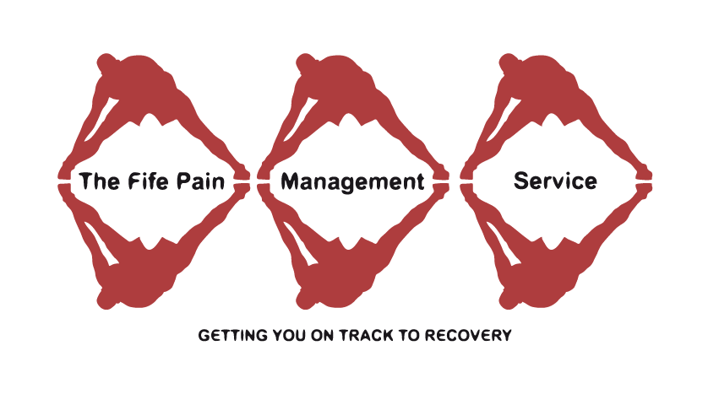

Suggested gabapentin reduction plan for chronic pain

Current dosage (2700mg) | Morning | Afternoon | Bedtime
 | 900mg  (3x300mg) | 900mg  (3x300mg) | 900mg  (3x300mg)
Reduce by 300mg
(2400mg) | 900mg  (3x300mg) | 600mg  (2x300mg) | 900mg  (3x300mg)
Reduce by 300mg
(2100mg) | 600mg  (2x300mg) | 600mg  (2x300mg) | 900mg  (3x300mg)
Reduce by 300mg
(1800mg) | 600mg  (2x300mg) | 600mg  (2x300mg) | 600mg  (2x300mg)
Reduce by 300mg
(1500mg) | 600mg  (2x300mg) | 300mg  (1x300mg) | 600mg  (2x300mg)
Reduce by 300mg
(1200mg) | 300mg  (1x300mg) | 300mg  (1x300mg) | 600mg  (2x300mg)
Reduce by 300mg
(900mg) | 300mg  (1x300mg) | 300mg  (1x300mg) | 300mg  (1x300mg)
Reduce by 300mg
(600mg) | 300mg  (1x300mg) | Nil | 300mg  (1x300mg)
Reduce by 300mg
(300mg) | Nil | Nil | 300mg  (1x300mg)
Reduce by 300mg
(0mg) | Nil | Nil | Nil
Requires gabapentin 300mg x 210

Suggested time period for each stage is seven days. If you do experience withdrawal effects or your pain increases then see advice above.
Your Plan for gabapentin reduction for chronic pain

This can be completed by your healthcare professional to support your reduction if different from example

Time

Current dosage
Reduce by ____mg
(____ mg)
A further ____mg
(____ mg)
A further ____mg
(____ mg)
A further ____mg
(____ mg)
A further ____mg
(____ mg)
A further ____mg
(____ mg)

Suggested pregabalin reduction plan for chronic pain

Current dosage (600mg) | Morning | Evening
 | 300mg  (1x300mg) | 300mg  (1x300mg)
Reduce by 75mg
(525mg) | 225mg  (1x150mg + 1x75mg) | 300mg  (1x300mg)
Reduce by 75mg
(450mg) | 225mg  (1x150mg + 1x75mg) | 225mg  (1x150mg + 1x75mg)
Reduce by 75mg
(375mg) | 150mg  (1x150mg) | 225mg  (1x150mg + 1x75mg)
Reduce by 75mg
(300mg) | 150mg  (1x150mg) | 150mg  (1x150mg)
Reduce by 75mg
(225mg) | 75mg  (1x75mg) | 150mg  (1x150mg)
Reduce by 75mg
(150mg) | 75mg  (1x75mg) | 75mg  (1x75mg)
Reduce by 75mg
(75mg) | 0mg  (Nil) | 75mg  (1x75mg)
Reduce by 75mg
(0mg) | 0mg  (Nil) | 0mg  (Nil)
Requires pregabalin 150mg x56 and 75mg x56 capsules (including 300mg x7 from current supply)

Suggested time period for each stage is seven days
If you do experience withdrawal effects or your pain increases then see advice above.

Your Plan for pregabalin reduction for chronic pain

This can be completed by your doctor, pharmacist or pain specialist to support your reduction if different from example

Time

Current dosage
Reduce by ____mg
(____ mg)
A further ____mg
(____ mg)
A further ____mg
(____ mg)
A further ____mg
(____ mg)
A further ____mg
(____ mg)
A further ____mg
(____ mg)

