Gabapentinoid Prescribing for Chronic Pain in Primary Care

Resources for Clinicians and Boards

VERSION 1.2 – 11th December 2018

Introduction

What is the purpose of this document?

The purpose of this document is to promote quality improvement in prescribing for adults with chronic pain across primary care in Scotland, particularly focussing on delivery of safe, person-centred care. In addition, it promotes self-management and non-pharmaceutical management of chronic pain and provides practical tools to support appropriate prescribing and patient review.

The scope includes review of the pharmaceutical and non-pharmaceutical management for adult patients only. The document is not intended to replace any current clinical guidance and should be used alongside SIGN 136.
This guidance provides information about the prescribing and review of gabapentin and pregabalin for chronic pain. A key step is careful consideration at the point of first prescription about whether gabapentinoids are indicated and whether there is a risk of medicine misuse. The importance of early and ongoing review is also clear. Non-pharmaceutical approaches should always be considered instead of, or alongside, medicines.
A quick reference document is available in appendix 7.
There is detailed information on pharmaceutical management of chronic pain, both at clinician and Board level, within Quality Prescribing for Chronic Pain [1] produced in 2018.
Contents
Introduction 2
Acknowledgements 3
Appropriate Prescribing of Gabapentinoids 4
Background Information 4
High risk patients 5
Review 6
How to achieve the correct dosage 6
How to reduce a patient’s dosage 7
Drug related deaths 7
Summary 8
Appendices 9
Appendix 1 – Local Contact Details 9
Appendix 2 – Treatment pathway for chronic pain 9
Appendix 3 – Pain Management Prescribing Agreement 10
Appendix 4 – Suggested Reduction Regimen 11
Appendix 5 - Principles for prescribing for patients with chronic pain 12
Appendix 6 – Identification of patients 13
Appendix 7 – Quick Reference Guide 14
References 15

Acknowledgements
This guidance was adapted from a resource developed by NHS Forth Valley. We are very grateful to the original authors both for their work and for their agreement to the development of a national version.
This version was developed by the Effective Prescribing and Therapeutics Branch of Scottish Government.
Lead authors of this version – Heather Harrison and Jason Cormack
With thanks to:
Blair H. Smith, National Lead Clinician for Chronic Pain, Scottish Government
Debbi Steven, Lead Pharmacist, NHS Fife Pain Management Service
Mini Mishra, Senior Medical Officer, Scottish Government
Mark Lawson and colleagues, Substance Misuse Unit, Scottish Government
Mike Bennett, Professor of Palliative Medicine, University of Leeds

Appropriate Prescribing of Gabapentinoids

Background Information
Gabapentinoids, when used appropriately, have been shown to be effective for some patients in the management of neuropathic pain. The table below [2] provides the number needed to treat (NNT) and number needed to harm (NNH) for both drugs. The NNT is based on patients achieving 50% pain relief with treatments lasting more than three weeks. The NNH is based on the number of patients that needed to be treated for one patient to drop out due to adverse effects.
Drug | NNT | NNH
Pregabalin | 7.7 (95% CI 6.5-9.4) | 13.9 (95% CI 11.6-17.4)
Gabapentin | 6.3 (95% CI 5.0-8.3) and  8.3 (95% CI 6.2-13) for extended release ER preparations | 25.6 (95% CI 15.3-78.6) and  31.9 (95% CI 17-230) for ER preparations
SIGN 136 [3] recommends amitriptyline or gabapentin as first line medicine in neuropathic pain, dependent on clinical preference and patient factors (including the risks discussed below). Pregabalin is an alternative in patients who have found no benefit from, or not tolerated, amitriptyline or gabapentin.
It is important to discuss patients’ aims for pharmacological treatment using the what matters to me [4] approach. The Pain Concern Navigator Tool [5] can be used to support discussion and enable the patient to be a partner in making decisions about their care. Realistic aims may include pain reduction (e.g. 30%) and/or functional goal improvement [1]. Further information on key principles for prescribing is available in appendix 5.
Gabapentinoids are not licensed for non-neuropathic pain, nor is there any evidence to support their use.
As with all medicines for the treatment of chronic pain, gabapentinoids should be used only as part of a wider management plan. Patients should be aware that non-pharmaceutical options or those offered along with prescribed medicines, may result in better achievement of goals and result in less harm than medicines alone. ALISS [6] is a helpful directory which signposts to local support.
For those with more complex needs, referral for specialist pain assessment should be considered.
Gabapentinoids will be reclassified class C controlled substances under section the Misuse of Drugs Act from April 2019 [7]. The law change will mean there will be stronger controls in place to ensure accountability and minimise the chances of pregabalin and gabapentin falling into the wrong hands or being stockpiled by patients. Clinicians would be encouraged to only prescribe 30 days’ supply.
Doctors will now need to physically sign prescriptions, rather than electronic copies being accepted by pharmacists. In addition, pharmacists must dispense the drugs within 28 days of the prescription being written.
The change means it will be illegal to possess pregabalin and gabapentin without a prescription and it will be illegal to supply or sell them to others.
Common side effects of gabapentin and pregabalin include dizziness, drowsiness and balance issues. With gabapentin, there have also been issues of respiratory depression, although this is not common. Caution should be shown when initiating gabapentin in patients with compromised respiratory function or neurological disease, renal impairment, and/or concomitant use of CNS depressants. Elderly people might be at higher risk of severe respiratory depression [8].

High risk patients
Gabapentinoids also have the potential for abuse and dependence this is particularly prevalent in people who misuse other drugs and in specific settings such as prisons [9]. Their mechanism for producing dependence is not yet well understood, though there may be direct or indirect effects on the dopaminergic ‘reward’ system [10]. There appears to be more evidence of misuse than for dependence, however the summaries of product characteristics for both medicines caution about dependence.
It is recommended that practitioners give careful consideration to the individual patient when prescribing pregabalin and gabapentin to minimise the risk of misuse, dependence, and diversion. Assessment of the balance of benefits and risks is essential.
Patients may source gabapentinoids illicitly. Referral to specialist substance misuse services is advised, as required, for assessment and psychological treatment of the underlying difficulties where the whole substance misuse picture will be considered.
Individuals at high risk of misusing or diverting gabapentinoids may include those who:
- Have a history of substance misuse
- Make specific requests for initiation of either gabapentin or pregabalin
- Request pregabalin or gabapentin following liberation from prison service
- Make repeated early prescription requests
- Repeatedly report lost medication – see appendix 6 for a useful tool
- Contact out of hours services for supplies of medication
Consider the following as part of the initial assessment:
- The risk of misuse
  - The opioid risk tool [11] may be useful in assisting with this determination
  - Consider the high risk factors above
- Whether there is a neuropathic component to pain
  - Gabapentinoids are not licensed for non-neuropathic pain.
  - The S-LANNS tool [12] may be useful
- Previous management options
  - Ensure 1st and 2nd line options have been trialled adequately, per local or national guidance
- A discussion on the risks of dependence [9]
  - Consider daily or weekly dispensing in at risk patients
Appendix 3 contains a template for a prescribing agreement, which may be of help with some patients to ensure all parties are clear on how to proceed.

Review
It is important that practices monitor gabapentinoid prescriptions both in the individual patient and at practice level. Review at the individual level should take place at around 4 weeks after initiation of treatment (or earlier if appropriate) to check signs of efficacy, tolerance and adverse effects. Further reviews and titration may be required for the next two months. The medicine should be stopped (normally this is done gradually- see below) if no improvement or insufficient improvement is seen after two months. Many patients whose pain is well controlled manage eventually to successfully reduce their dose of gabapentinoids, and they should be invited to try this, with support in trying to do it. Subsequent review should take place at least annually, more frequently in high risk patients and those who are having their dose changed (increased or decreased).
Repeat prescribing of gabapentinoids must be avoided in high-risk patients unless there are strict processes in place to monitor for over-ordering and dispensing. Consider adopting a practice analgesic policy [13]
Patients who have been receiving gabapentinoid prescriptions should be reassessed at least annually, to establish ongoing need and risk of misuse. The original indication for the prescription should be discussed and alternative treatments considered, per SIGN 136 [3].
Patients may require support and advice about pain management. These include SIGN Guideline for Patients [3], which also lists useful materials and websites. Referral to Pain Association Scotland, Pain Concern, or other self-management supports should be actively encouraged offered as required All review of medicines should be conducted in a holistic way. Further information is available within Scottish Government Polypharmacy Guidance [14].

How to achieve the correct dosage
The following principles may be useful in the process of determining the correct dose for a patient: Useful patient information leaflet on medicines for long term pain are available from Pain Concern [15].
- A titrated approach, taking into consideration patient characteristics, e.g. elderly, renal impairment, breast feeding etc. to initiation of both gabapentin and pregabalin is recommended.
  - Gabapentin usually starts at 300mg at night and titrates upwards usually by 300mg per week. Evidence suggests that a minimum of 1200mg is needed and doses may need to be increased to the maximum of 3600mg.
  - Pregabalin usually starts at 75mg twice daily up to a maximum of 300mg twice daily. This would be managed according to side effects and clinical effectiveness.
- Regular review should be scheduled, particularly during the initiation phase. Medication should be stopped if there is no, or insufficient effect (see page 4 for NNTs)
- A trial of dose reduction/cessation should be undertaken, following a period of stability
- Stepping up should be closely monitored. Dispense daily or weekly in high-risk patients
- Aim to maintain patients on the minimum dose which controls pain
- Where patients fail to engage with the review process, consideration should be given to gradual dose reduction and withdrawal of gabapentinoid prescription

How to reduce a patient’s dosage
Both gabapentin and pregabalin doses should normally be gradually reduced to minimise symptoms of withdrawal and allow assessment of response. The following principles may be useful:
- A trial of dose reduction/cessation should be undertaken, following a period of stability
- A suggested reduction regime for analgesic use would be:
- Gabapentin – reduce at maximum daily rate of 300mg every week
- Pregabalin - reduce at maximum daily rate of 50-100mg every week
- A full suggested reduction regime is available in appendix 4
- In high risk patients, temporarily halt reduction, in preference to re-escalating the dose when required
- Rapid reduction to stop is justified if there is clear evidence of attempts to divert or obtain illicit supplies of gabapentin or pregabalin
In practice, reduction regime may be adjusted depending on individual response and degree of associated risk.
A sample information leaflet, developed originally by NHS Fife, is available here [16].

Drug related deaths

In 2008, National Records for Scotland reported two drug related deaths where gabapentin was implicated in, or partially contributed, to death (pregabalin was not considered to have been implicated in any drug related deaths in 2008). However, by 2017, the number of deaths in which gabapentinoids were implicated in (or partially contributed to) had increased to 242 (122 gabapentin only; 100 pregabalin only and 20 gabapentin and pregabalin). While this is a significant increase in numbers, it should be noted that the total volume of prescribing of gabapentinoids across Scotland has also increased.
Public Health England has provided information on the risks of gabapentinoids [9]. Professionals prescribing pregabalin and gabapentin should be aware not only of the potential benefits of these drugs to patients, but also that the drugs can lead to dependence and may be misused or diverted.
Gabapentin and pregabalin are associated with significant euphoric effects. Individuals misusing gabapentin and pregabalin variably describe improved sociability, euphoria, relaxation and a sense of calm. Gabapentin and pregabalin have the propensity to cause depression of the central nervous system, resulting in drowsiness, sedation, respiratory depression and at the extreme, death.
The pharmacokinetic properties of pregabalin make the drug relatively more dangerous than gabapentin in high doses. Pregabalin misusers are achieving the effects above by taking large quantities, ranging from 200mg to 5g as a single dose.
Both gabapentin and pregabalin have adverse effects on the central nervous system, which are additive when used with other centrally acting drugs, particularly opioids.
Currently, pregabalin appears to be more sought after for misuse than gabapentin.

Summary
Gabapentin and pregabalin should be prescribed appropriately in the management of neuropathic pain, while taking appropriate steps to minimise the risk of misuse and diversion. Caution, with due consideration of first line options, and special care exercised in the substance misusing population is required to help minimise the risk of misuse and diversion. Early and ongoing review is essential for all patients prescribed gabapentinoids. Extreme care should be taken when co-prescribing gabapentinoids and opioids.

Appendices

Appendix 1 – Local Contact Details

Boards may already have health improvement and support directories available; however those without this facility may wish to use this space to provide up to date contact details of relevant local services. Examples include:

- Specialist secondary care clinic(s)
- Community drug and alcohol services
- Mental health support
- Addiction support
- Counselling

It is suggested that the following information be included for these services:

- Opening hours
- Contact details (phone, email)
- Address of any in-person service
- Aim of service

Appendix 2 – Treatment pathway for chronic pain
Boards may wish to include a link to their local treatment pathway at this point or the neuropathic pain pathway algorithm contained within SIGN 136 [3].

Appendix 3 – Pain Management Prescribing Agreement
The below Pain Management Prescribing Agreement may be useful in some cases (for instance with high risk patients), to ensure and document the patient’s understanding of their treatment. It is not recommended for all patients and clinical judgement is required. Boards, clusters or practices may wish to tailor it to their needs.
Pain Management Prescribing Agreement
Name ............................................................................................................................
Date of birth.......................................................
As part of my treatment plan which includes prescribing pain relief medicines I agree to the following conditions:
- I am currently taking ________mg of ________________________daily
- I agree to fully participate in the pain management plan as outlined in my medical record. As part of this plan I will be referred to other specialist and agree to engage fully in all treatments offered.
- If I do not adhere to the agreed programme, I accept that my prescribed pain relief medicines will be reviewed and may be reduced.
- I acknowledge that I should not take any additional pain relief medicines unless under the advice of a clinician.
- I agree not to sell or otherwise dispose of medication prescribed to me.
- I agree to the medicines being dispensed daily / weekly [delete as appropriate].
- I understand that early requests for medicines will not be granted.

Signed (patient) ...................................................................................................................
Signed (on behalf of service) ...............................................................................................
Date.............................................................................

Appendix 4 – Suggested Reduction Regimen

Gabapentin
Suggested gabapentin reduction regime from 1200mg TDS
Gabapentin | Morning | Afternoon | Night | No. 300mg capsules
Week 1 | 1200mg (i.e. 4 x 300mg) | 900mg (i.e. 3 x 300mg) | 1200mg (i.e. 4 x 300mg) | 77
Week 2 | 900mg | 900mg | 1200mg | 70
Week 3 | 900mg | 900mg | 900mg | 63
Week 4 | 900mg | 600mg | 900mg | 56
Week 5 | 600mg | 600mg | 900mg | 49
Week 6 | 600mg | 600mg | 600mg | 42
Week 7 | 600mg | 300mg | 600mg | 35
Week 8 | 300mg | 300mg | 600mg | 28
Week 9 | 300mg | 300mg | 300mg | 21
Week 10 | 300mg | - | 300mg | 14
Week 11 | - | - | 300mg | 7

Pregabalin
Suggested pregabalin reduction from 300mg BD
Pregabalin* | Morning | Night
Week 1 | 250mg | 300mg
Week 2 | 250mg | 250mg
Week 3 | 200mg | 250mg
Week 4 | 200mg | 200mg
Week 5 | 150mg | 200mg
Week 6 | 150mg | 150mg
Week 7 | 100mg | 150mg
Week 8 | 100mg | 100mg
Week 9 | 50mg | 100mg
Week 10 | 50mg | 50mg
Week 11 | 25mg | 25mg
Week 12 | - | 25mg

*prescribe pregabalin generically
In practice, reduction regime may be adjusted depending on individual response and degree of associated risk

Appendix 5 - Principles for prescribing for patients with chronic pain
Principle | Detail
Early Assessment | Early assessment and characterisation of pain type is crucial in guiding treatment. Many drugs that are specifically effective in neuropathic pain are ineffective in other types, and vice versa [2]. SIGN 136 [3] pathways are recommended for assessment and management. Consider high risk patient groups and patient risk factors, including misuse/abuse potential.
Planning and Patient Understanding | It is important that patients understand their condition and have appropriate expectations. Medication should be considered as part of the management of chronic pain: patients should understand that medication will not “cure” chronic pain and they need to engage in self-management, for example the pain toolkit [18]. It is vital the short and long term treatment plan, and any changes are discussed with and agreed by the patient along with arrangements for repeat prescribing.
Realistic Aims | It is important to discuss patients’ aims for pharmacological treatment. Realistic aims may include pain reduction (≥30%) and/or functional goal improvement. Stepping down should be discussed as part of initiation. Patient understanding can be explored using teach-back [19].
Record Consumption | Record all analgesic consumption including OTC medication and identify complementary therapies. Recording of the Read code 1M52 is strongly recommended for audit, review and quality improvement [20].
Stepped Approach | Apply a stepped approach to pain management and review regularly. Remember that there is both a step up and step down approach and that patients should be empowered to safely reduce their medications where appropriate. NSAIDs (including topical) and adjuvants can be considered at each step.
Early Review | Any drug initiated for chronic pain should be subject to early, frequent and recorded review with the patient. It should be titrated up to a dose which balances maximum clinical efficacy with minimal risk, and gradually stopped if found to be ineffective or if adverse effects outweigh benefits. This particularly applies to medicines with common serious adverse effects or abuse potential, and/or that are expensive to prescribe [1].
Ongoing Review | Once the dose is stable and effectiveness has been established, ongoing recorded review should occur at least every six to twelve months - more frequently if needed, for example due to flare-ups. This review should: confirm ongoing need for and effectiveness of medication; screen for side effects; and adjust dose or discontinue prescription as appropriate. A holistic Polypharmacy [14] approach is recommended.
Effective Care | Multimodal analgesia is most effective but requires using medicines with different mechanisms of action to deliver additional or synergistic impact: inappropriate polypharmacy should be avoided. Use the minimum effective or tolerated dose and step up as required. Start low and go slow.

Appendix 6 – Identification of patients
The Scottish Therapeutics Utility (STU) is a software programme aimed at improving the quality of repeat prescribing, available to all practices in NHS Scotland free of charge. STU is entirely practice based and is generally updated each night. There are two searches within the system which are of benefit in reviewing prescribing of gabapentinoids. These are:
1. Search 3, which looks at duplicate issues – specifically repeat items which have been issued more than once in a three day period, excluding reprints. The reprint functionality aims to prevent the same prescription being dispensed twice, for instance if a patient has lost the first prescription. The search therefore only includes medicines which would be dispensed twice by pharmacies.
The screenshot below shows the data tables, which can be ordered alphabetically by the drug column (by clicking on the heading at the top of the column). By identifying repeat medicines issued more than once in three days, this may represent an opportunity to detect misuse or diversion.
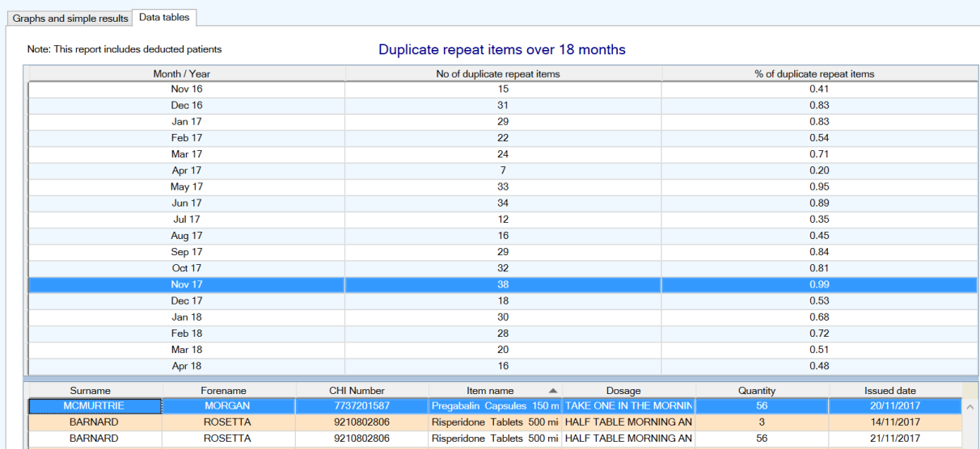
2. The recently released chronic pain searches, which identify patients prescribed more than 2 defined daily doses (DDDs) of gabapentinoids, and who may benefit from a review. The screenshot below demonstrates the search and how this is displayed. Other searches within this group focus on opioids, which may also be of interest.
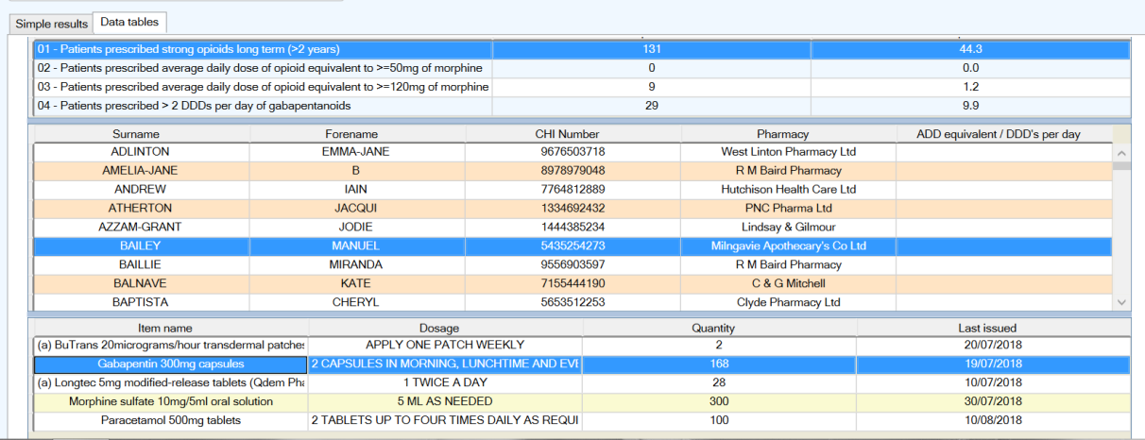

Appendix 7 – Quick Reference Guide
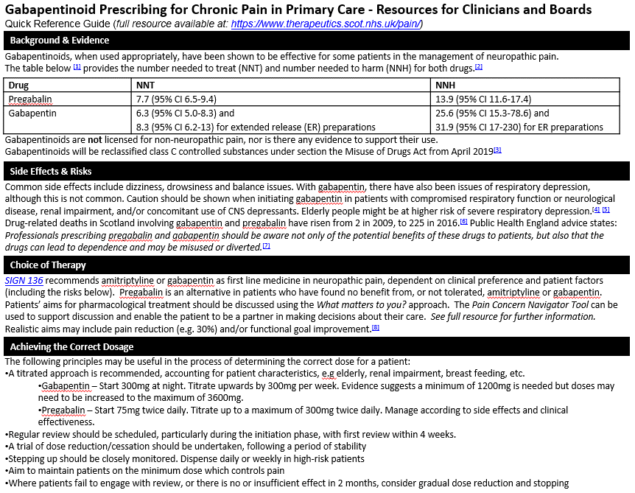
Appendix 7 Cont.
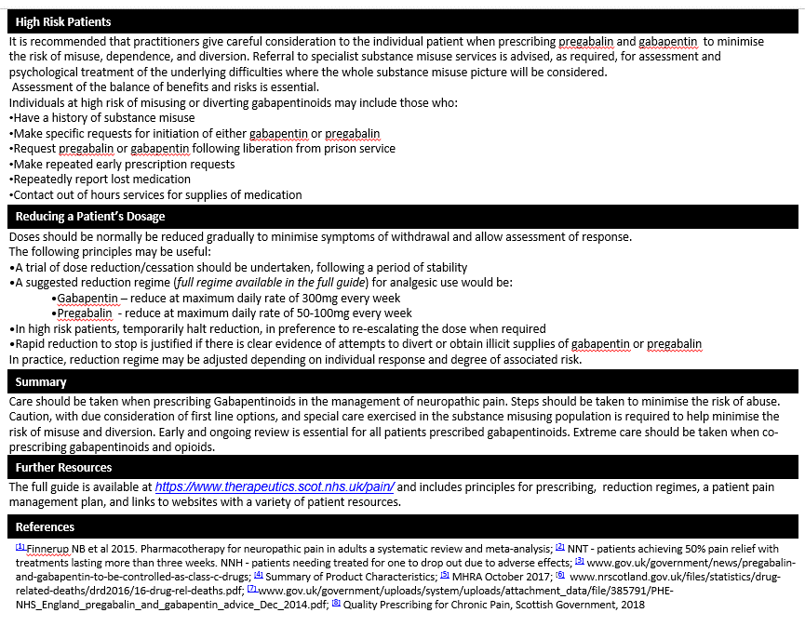

References

[1] |  | Effective Prescribing and Therapeutics Branch, Scottish Government, “Quality Prescribing for Chronic Pain - A Guide for Improvement 2018-2021,” 2018. [Online]. Available: https://www.therapeutics.scot.nhs.uk/wp-content/uploads/2018/03/Strategy-Chronic-Pain-Quality-Prescribing-for-Chronic-Pain-2018.pdf. [Accessed 7th November 2018].
[2] |  | N. e. a. Finnerup, “Pharmacotherapy for neuropathic pain in adults: a systematic review and meta-analysis,” The Lancet, vol. 14, no. 2, pp. 162-173, 2015.
[3] |  | Scottish Intercollegiate Guidelines Network (SIGN), “Management of chronic pain. SIGN publication no. 136,” 2013. [Online]. Available: https://www.sign.ac.uk/assets/sign136.pdf. [Accessed 7 November 2018].
[4] |  | Healthcare Improvement Scotland (HIS), “Why is it important to ask ‘what matters?’,” [Online]. Available: http://www.whatmatterstoyou.scot/why-is-it-important-to-ask-what-matters/. [Accessed 7 November 2018].
[5] |  | Pain Concern, “Research - Navigator Tool,” [Online]. Available: http://painconcern.org.uk/research/. [Accessed 13 November 2018].
[6] |  | A Local Information System for Scotland (ALISS), “Connecting Communities,” 2018. [Online]. Available: https://www.aliss.org/. [Accessed 7 November 2018].
[7] |  | Home Office and Victoria Atkins MP, “Pregabalin and gabapentin to be controlled as class C drugs,” 15 October 2018. [Online]. Available: https://www.gov.uk/government/news/pregabalin-and-gabapentin-to-be-controlled-as-class-c-drugs. [Accessed 7 November 2018].
[8] |  | British National Formulary (BNF), “Gabapentin,” 2 October 2018. [Online]. Available: https://bnf.nice.org.uk/drug/gabapentin.html#cautions. [Accessed 7 November 2018].
[9] |  | NHS England and Public Health England, “Advice for prescribers on the risk of the misuse of pregabalin and gabapentin,” December 2014. [Online]. Available: https://assets.publishing.service.gov.uk/government/uploads/system/uploads/attachment_data/file/385791/PHE-NHS_England_pregabalin_and_gabapentin_advice_Dec_2014.pdf. [Accessed 7 November 2018].
[10] |  | Clinical Guidelines on Drug Misuse and Dependence Update 2017 Independent Expert Working Group, “Clinical Guidelines on Drug Misuse and Dependence Update 2017,” November 2017. [Online]. Available: https://assets.publishing.service.gov.uk/government/uploads/system/uploads/attachment_data/file/673978/clinical_guidelines_2017.pdf. [Accessed 7 November 2018].
 | [11] |  | W. R. Webster LR, “Predicting aberrant behaviors in opioid-treated patients: preliminary validation of the Opioid Risk Tool,” Pain medicine, vol. 6, no. 6, pp. 432-442, 2005.
 | [12] |  | B. H. S. N. T. a. J. P. Michael I. Bennett, “The S-LANSS Score for Identifying Pain of Predominantly Neuropathic Origin: Validation for Use in Clinical and Postal Research,” American Pain Society, vol. 6, no. 3, pp. 149-158, 2005.
 | [13] |  | “Sample Practice Chronic Pain Analgesic protocol,” 2018. [Online]. Available: https://www.therapeutics.scot.nhs.uk/pain/. [Accessed 8 November 2018].
 | [14] |  | Effective Prescribing and Therapeutics branch, Scottish Government, “Polypharmacy,” [Online]. Available: https://www.therapeutics.scot.nhs.uk/polypharmacy/. [Accessed 13 11 2018].
 | [15] |  | Pain Concern, “Medicines for long-term pain,” 27 October 2017. [Online]. Available: http://painconcern.org.uk/medicines-long-term-pain/. [Accessed 13 11 2018].
 | [16] |  | NHS Fife Integrated Pain Management Service, “Chronic Pain Prescribing Strategy,” December 2016. [Online]. Available: https://www.therapeutics.scot.nhs.uk/pain/. [Accessed 13 11 2018].
 | [17] |  | National Records of Scotland, “Drug Related Deaths in Scotland,” 3 July 2017. [Online]. Available: https://www.nrscotland.gov.uk/statistics-and-data/statistics/statistics-by-theme/vital-events/deaths/drug-related-deaths-in-scotland. [Accessed 13 November 2018].
 | [18] |  | P. Moore, “The Pain Toolkit,” 2018. [Online]. Available: https://www.paintoolkit.org/. [Accessed 13 November 2018].
 | [19] |  | Scottish Health Council, “Teach-back,” February 2014. [Online]. Available: http://www.scottishhealthcouncil.org/patient__public_participation/participation_toolkit/teach-back.aspx#.W-p-MU1LHbg. [Accessed 13 November 2018].
 | [20] |  | Smith et al, “Scottish School of Primary Care GP Clusters Briefing Paper 2,” 5 September 2016. [Online]. Available: http://www.sspc.ac.uk/media/media_484727_en.pdf. [Accessed 13 November 2018].

The validity of this tool for gabapentinoids has not been tested. Expert opinion suggests it may be helpful.
These numbers are from a bespoke Information Request from ISD to NRS
Note earlier comments about evidence on dependence.
The screenshots contains dummy data – no real patient information is displayed.

