Scottish
Therapeutics
Utility

Installation Guide

Contents

Aim 1
Scope 1
Definition of Terms 1
Process 2

Aim

The aim of this document is to show the user how to install the Scottish Therapeutics Utility (STU) GP Practice computer program.

Scope

All staff should follow this procedure. Failure to follow this may result in failure to install or incorrect installation of the program.

If using a printed ‘hard’ copy of this document the user should identify that the copy is current by checking the version against the equivalent electronic document on the Effective Prescribing & Therapeutics Division website.

Definition of Terms

The Scottish Therapeutics Utility (STU): STU was developed to help improve safety, optimise efficiency and reduce avoidable waste in prescribing systems, and is freely available to each GP practice in Scotland. STU provides access to various technical (housekeeping searches such as duplicate and obsolete drugs) and clinical (such as polypharmacy and patient safety) reports. The information in STU is based on an extract from the GP system, updated from the previous day and earlier. STU is intended for use both by clinicians and administrative staff.

Process

Installing the Scottish Therapeutics Utility

- Check that STU is not already installed. If it is there will be an icon on the Desktop:

Double click the icon to open. If there is an error message when the icon is double clicked to open, click once on it to select then press the Delete key and click Yes to confirm deletion. Install as from 2.

- Go to http://www.escro.co.uk/ then click Install STU
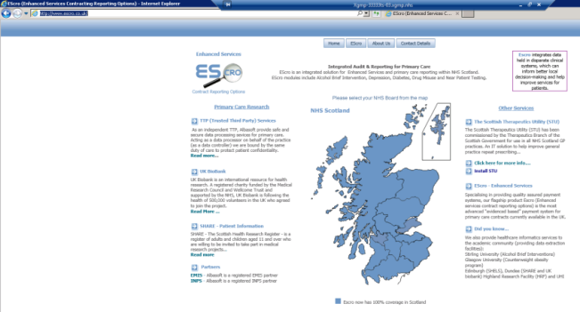

- Click Install
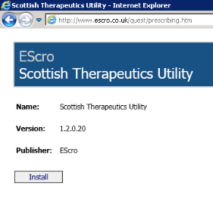

- A launching application window will open briefly
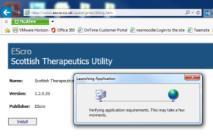

- Click Install
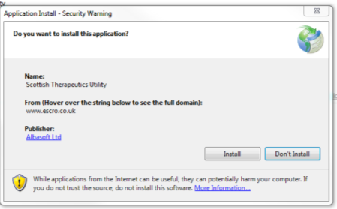

- Installing window will open
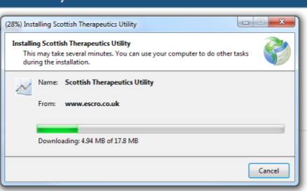

- Welcome window will open. Click OK
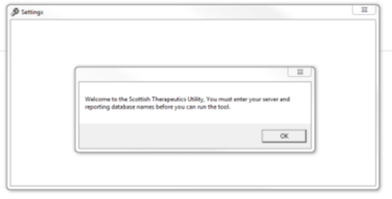

- Enter the 5 digit Practice Code then click Get server & database settings
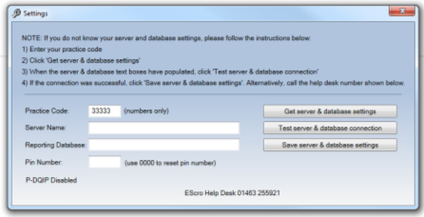

- Server Name and Reporting Database name boxes will populate. Click Test server & database connection
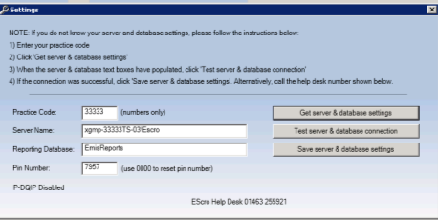

- Connection Successful box pops up. Click OK. Click Save server & database settings
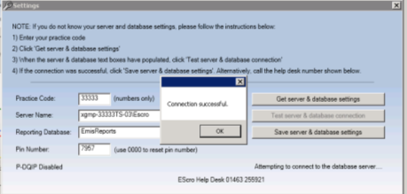

STU will open and display data.

For errors during installation, contact the EScro Helpdesk on: 01463 255921

For instructions and further guidance go to the Effective Prescribing & Therapeutics Division website: https://www.therapeutics.scot.nhs.uk/stu/

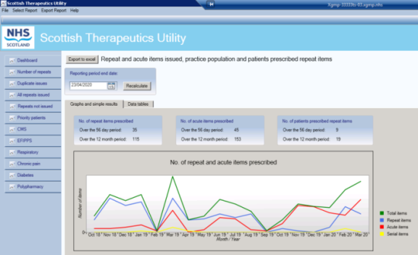

- In future, double click the STU on the Desktop to Open.

