

**Scottish**

**Therapeutics**

**Utility**

**User Guide**



**Contents**

[1 Introduction 1-1](#_Toc79483284)

[2 How to use STU 2-1](#_Toc79483285)

[STU Navigation 2-2](#_Toc79483286)

[Format of STU 2-4](#_Toc79483287)

[Additional Functionality 2-6](#_Toc79483288)

[3 Available Reports 3-7](#_Toc79483289)

[Report: Dashboard 3-8](#_Toc79483290)

[Report: Number of repeats 3-9](#_Toc79483291)

[Report: Repeatable acutes 3-12](#_Toc79483292)

[Report: Duplicate issues 3-14](#_Toc79483293)

[Report: All repeats issued 3-16](#_Toc79483294)

[Report: Repeats not issued 3-18](#_Toc79483295)

[Report: Priority patients 3-20](#_Toc79483296)

[Report: CMS 3-22](#_Toc79483297)

[Report: Effective Feedback to Improve Primary Care Prescribing Safety (EFIPPS) 3-24](#_Toc79483298)

[Report: Respiratory 3-26](#_Toc79483299)

[Report: Chronic Pain 3-28](#_Toc79483300)

[Report: Antidepressants, benzodiazepines and z-drugs 3-30](#_Toc79483301)

[Report: Diabetes 3-31](#_Toc79483302)

[Report: Polypharmacy 3-32](#_Toc79483303)

[Report: Clinical safety checks 3-34](#_Toc79483304)

[EScro Data Pump 3-35](#_Toc79483305)

# Introduction

The Scottish Therapeutics Utility (STU) has been commissioned by the Effective Prescribing & Therapeutics Division of the Scottish Government for use in all NHS Scotland GP practices. It was developed following a drive to improve safety, optimise efficiency and reduce avoidable waste (processes and costs), particularly in relation to repeat prescribing.

STU is intended for use by healthcare professionals and GP practice staff to monitor and review repeat prescribing systems at practice level. The utility allows users to interrogate their prescribing in real time and provides graphs to identify trends in repeat prescribing. Matters such as duplicate prescribing, ‘repeatable’ acutes, non-issued items and excessive issues over and above the prescribing interval are highlighted and can be prioritised for corrective action.

As well as graphs, the application provides data tables showing the figures returned by the database query and, where appropriate, the patient details and drug items associated with the report.

STU also incorporates reports which identify three cohorts of priority patient groups subject to the application of the appropriate read codes; those resident in a care home, those receiving medication in a multi-compartment compliance aid, and those patients registered for the Chronic Medication Service.

Additionally, STU now includes a variety of clinical reports which identify areas of high risk prescribing to support clinicians to review those individuals to determine if prescribing is still necessary, or how the risk can be reduced. These include reports based around respiratory, diabetes, chronic pain, polypharmacy and related to the EFIPPS (Effective Feedback to Improve Primary Care Prescribing Safety) study.

#### Who is this guide for?

This guide is produced for anyone who uses STU in the workplace. It can also be used as a resource by anyone responsible for delivering training on STU.

All screenshots shown in this guide are based on a dummy database and therefore contain no ‘real’ identifiable patient information.

#### Getting help

Technical issues and installation queries regarding the Scottish Therapeutics Utility should be directed in the first instance to the EScro Helpdesk on 01463 255921.

Further support in interpretation of reports may be available from your local Prescribing Support Team or access the document ‘Understanding your STU data’, available at: <https://www.therapeutics.scot.nhs.uk/stu/>.

***Installing STU***

To install STU go to [www.escro.co.uk](http://www.escro.co.uk) then click *Install STU*.

1. After download an installation window will appear. Enter your 5 digit practice code in the *Practice Code* box then click the button *Get server & database settings*. The *Server Name* and *Reporting Database* boxes should auto-populate.

The *Pin Number* box is used for testing searches in development and should be left as *0000* unless directed to enter a pin number.

1. Click the button *Test server & database connection*. A message box should appear to say that the connection is successful (if not, contact the EScro helpdesk on the number above), click *Ok*.
2. Click the button *Save server & database settings* to finish the installation and open STU.

***Logging in***

To run the application, click on the STU report_chart icon on your desktop, or click on **Start | All Programmes | EScro | Scottish Therapeutics Utility** on the menu bar.

The application can be run at any time, however you may find it most useful to run at the beginning of each month or after work has been completed such as clinical or non-clinical medication review. The application runs against a small reporting database created by the EScro Data Pump – see [EScro Data Pump 3-35](#_EScro_Data_Pump).

When you first run the STU application, the STU window will display the Dashboard with the ‘Graphs and simple results’ tab selected and a reporting period end date of today’s date.

***Troubleshooting***

If some, or all, of the charts and tables are empty, someone with access to the EScro data Pump should check it has been running on a scheduled task – see EScro Data Pump 3-25.

# How to use STU



## STU Navigation

STU is simple to navigate around and use.

***Accessing STU reports***

There are two ways to access the reports in STU.

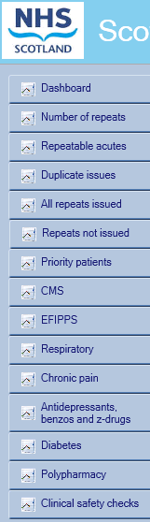 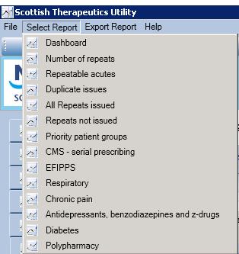

Click **Select Report** from the top menu then click to navigate to a report.

Click the report name in the listing on the left hand side from within STU.

***Exporting STU results***

STU results can be exported to MS Excel for further editing or statistical analysis.

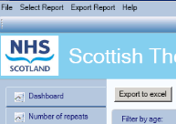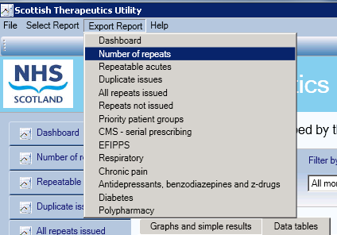

You can export reports either from the **Export Report** menu on the menu bar, or the **Export to excel** button shown on the report.

***STU Help***

Help information is available from within STU.

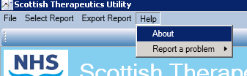

Click **Help** then **About** from the top menu.

A window will pop up with status information. This includes connection details, version information, Data Pump last run date, and helpdesk contact details.

The Data Pump runs to update STU on a nightly basis. If the most recent run date is more than 1 day ago, contact the EScro helpdesk.

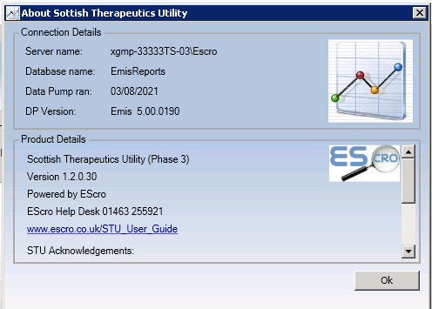

***Accessing STU settings***

Occasionally it may be necessary to access STU settings to reconfigure the connection e.g. where your practice code, server name or reporting database name changes.

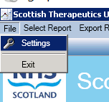

Click **File** then **Settings** from the top menu to access settings.

## Format of STU

Across the various reports, STU has two main formats. The first is displayed below: graphs and simple results.

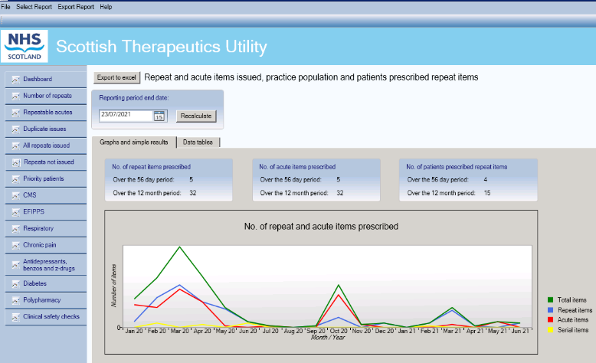

List of available reports

Use calendar to specify results period.

Description of selected report.

**Data tables** tab shows detailed results – see following page.

***Graph area***

The Graph area shows the results for the chosen search, usually as a monthly trend over the specified time period. Some reports show more than one graph – use the scroll bar to view all graphs available where appropriate.

***Data tables tab***

The second format is the ‘Data tables’ tab, which shows the results of the selected search in more detail than the ‘Graphs and simple results’ tab. Pictured below is an example of the ‘Data tables’ tab for 2 - Number of repeats – *Patients grouped by the number of active repeat items.*

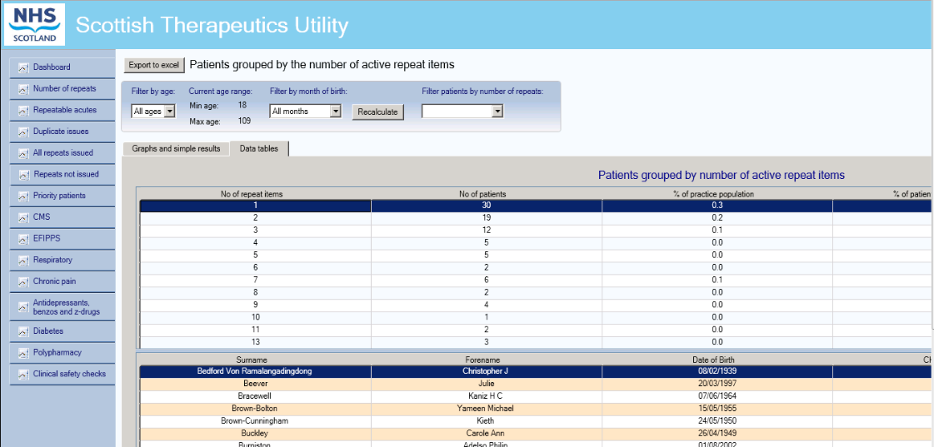

Click on the **Data tables** tab for more detailed results.

Select an age band, month of birth and / or number of repeat items from the top grid; this will filter your results in the grid below.

Clicking on a patient’s name will display their list of repeat items in the grid below that.

Information Points:

The Data tables for the Dashboard are simply tables of the figures used to produce the graphs in the ‘Graphs and simple results’ tab.

For all other reports, such as the one pictured above, the Data tables are tiered to display further information – see Section 3 for more details about what information is available in the ‘Data tables’ tab of each report.

The data tables can be sorted in each section by clicking on the headings. For example, you can numerically order the top table by clicking on the *No. Of patients* heading. This functionality applies to any of the other headings and sorting will be either numerical or alphabetical depending on the data context. The same applies to the tiered tables underneath. Clicking on the heading again will arrange the information in reverse order.

Anywhere you see a patient’s name, you can right click on the name and enter the patient’s clinical record within EMIS or Vision. You must ensure the clinical system is open, and for Vision users, Consultation Manager must also be open.

## 

## Additional Functionality

***View items issued***

For all the patient drill down tables you can right click on the patient name and select ‘View items issued’ to view a history of the current repeat items issued to that patient over the last 12 issues and for the last 12 calendar months. This opens a matrix which can be reviewed to rapidly assess potential compliance/concordance issues.

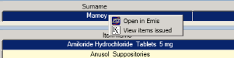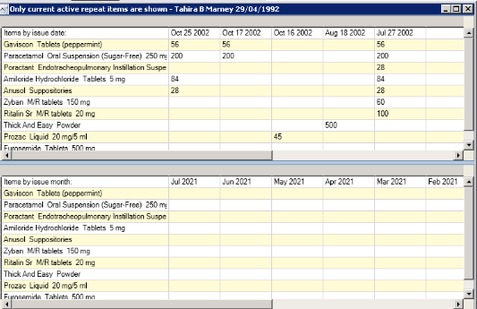

Right click on the patient’s name and select **View items issued**.

Issues can be viewed by date issued.

They can also be viewed by the issue month.

*Adding a medication management read code*

You can also open the patient’s record in Vision or EMIS, directly from the drill down table. A pre-designated medication management Read code (8BM..), can also be entered into a patient’s record. Free text can be added along with the read code to give details of the action required to be taken. You can open the patient’s record from any of the patient drill down tables.

*NB Adding a medication management code is only available in ‘5 - Repeats not issued’ report.*



Note: The clinical system must be open to view a patient’s record.

# Available Reports



## Report: Dashboard

**Repeat and acute items issued, practice population and patients prescribed repeat items**

The dashboard is the first window displayed when STU is opened. It shows the total number of active repeat, acute and serial prescription items prescribed over the 56 day and 12 month periods ending on the selected reporting period end date. The summary data in STU relates to the most recent full month. The data table data in STU relates to the previous day, in line with the automated run of the EScro data pump. Where this is not the case e.g. the data pump has stopped running and the data is out of date, STU will provide an alert within a pop-up window.

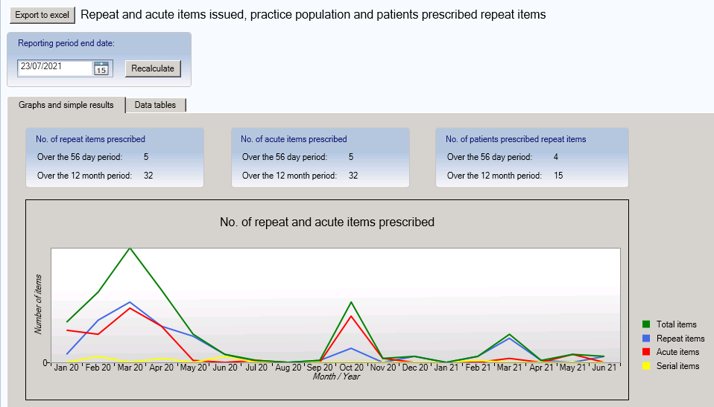

***Graph***

**Graph 1:** The trend of the number of repeat items, acute items, serial items, and total items issued over the 18 calendar months prior to the selected reporting period end date.

***Data tables***

The data tables show the trend of the above information, broken down by month.

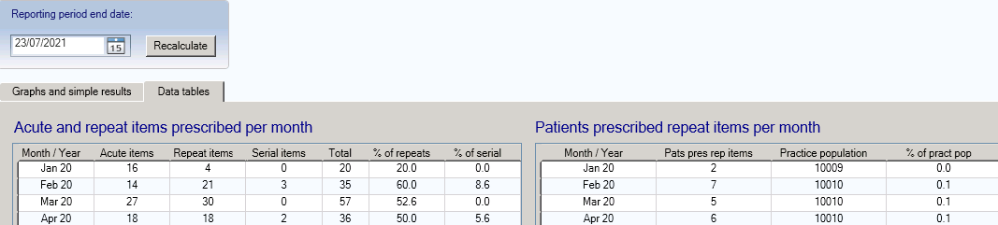

## Report: Number of repeats

**Patients grouped by the number of active repeat items**

Click on the report title from the menu on the left of the screen to bring up the second search. The graphs are explained below.

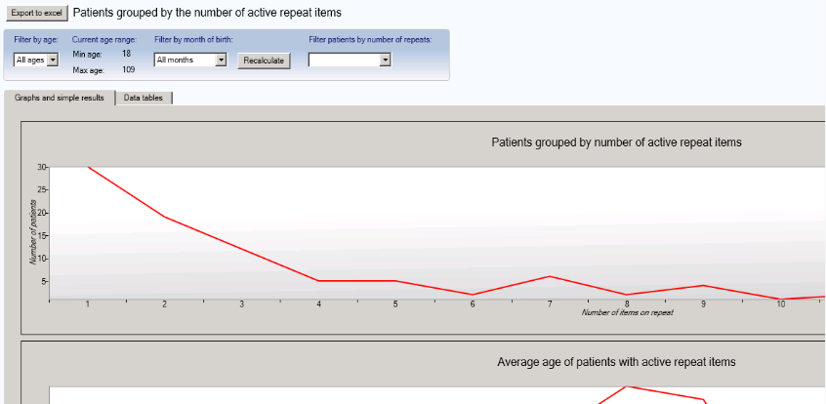

Select an age range to filter result by age.

Select a month to filter result by month.

Select the number of repeats range to filter result by that range.

You can change the age range you would like to view, with the default being all ages. You can filter by month of birth, with the default being all months. You can filter by a number of repeats range, with the default being all repeats. Selecting one or more filters then clicking on recalculate will update the data presented in all four graphs and charts.

***Graphs (shown above)***

**Graph 1:** The number of patients with a given number of active repeat items.

**Graph 2:** The average age of patients with a given number of active repeat items.

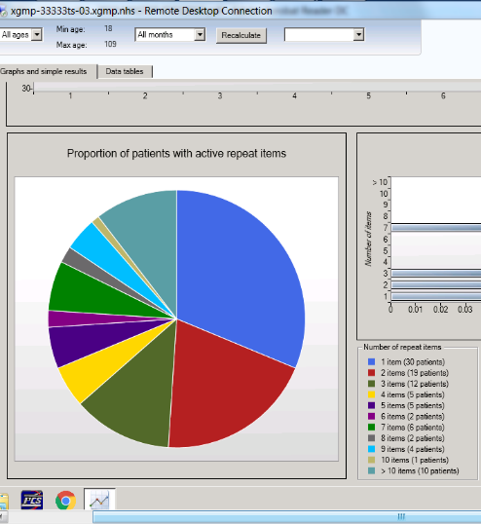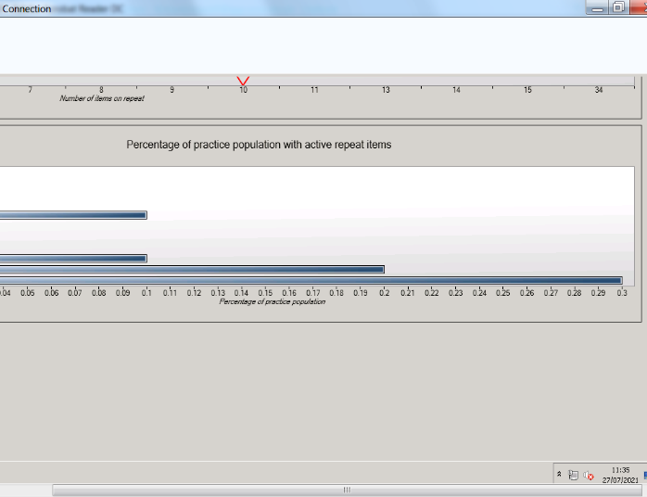

**Graph 3:** Pie chart showing the proportion of patients with a given number of active repeat items. Hovering the mouse over any given segment will reveal the number and percentage of patients within that group.

**Graph 4:** Bar chart showing the percentage of the practice population with a given number of active repeat items.

***Data tables***

Click on the data tables tab to show more detailed information about the search.

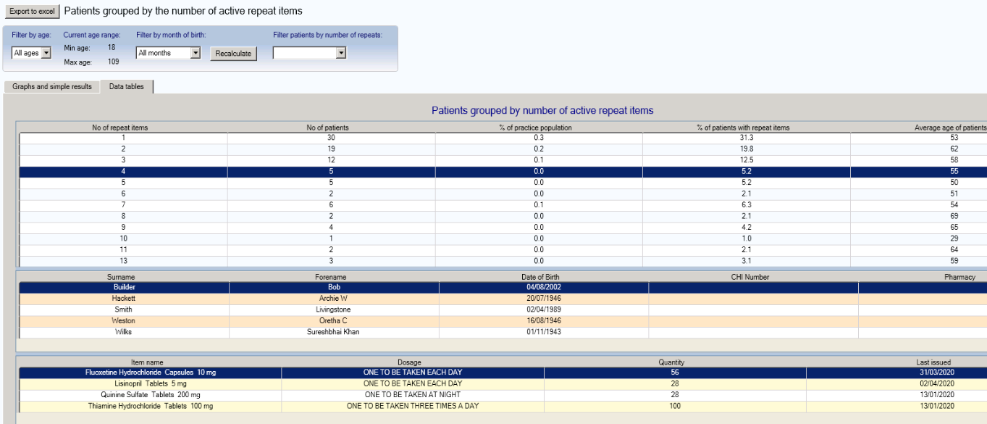

The ‘Data tables’ tab lists the number of active repeat items patients have authorised on the clinical system.

It also shows how many patients are on the selected number of active repeat items and what percentage this represents of both the practice population and of the total number of patients with active repeat items.

Finally, it shows the average age of those patients with the selected number of active repeat items.

For example, in the above table (based on dummy data), there are 5 patients who have 4 active repeat items, representing 0.01% of the practice population and 5.2% of all patients with active repeat items. The average age of patients with 4 active repeat items is 55 years.

Note: The second table(middle in the above screenshot) shows the drill down of the individual patients’ names, and the third (bottom in the above screenshot) shows the repeat items authorised for the selected patient.

Where a Pharmacy is displayed, please note that this is as currently annotated on the clinical system by the practice with the exception of patients who are registered for the Chronic Medication Service (CMS) via Community Pharmacies. Where patients are registered for CMS, any pharmacy annotated by the practice will be over-written in STU to display the CMS registering pharmacy only.

## Report: Repeatable acutes

**Patients grouped by the number of identical acute items, issued within a defined number of months**

This report helps identify patients who have received ‘repeatable’ acutes, those acutes issued more than once within a given time period.

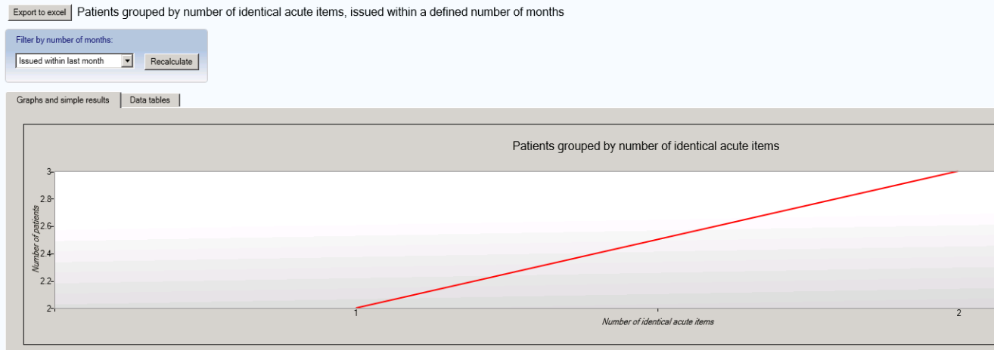

***Simple results***

The blue filter box allows filtering the results by a number of user selectable months. The recalculate button should be clicked if the filter criteria is changed.

***Graph (shown above)***

The number of identical acute items grouped by the number of patients.

***Data tables***

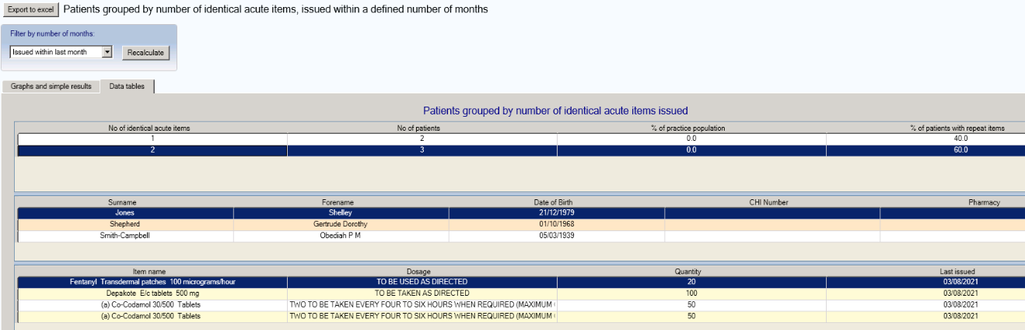

The ‘Data tables’ tab shows the number of identical acute items issued within the selected time period, the number of patients, and what percentage the number represents of the practice population and of patients with repeat items.

For example, in the table above within the last month there were 3 patients each with 2 identical acute items, representing 0.01% of the practice population and 60% of patients with active repeat items for that month.

In the patient level detail displayed in the lower tier table acute prescribing is annotated (a). Repeat prescribing is also shown for information.

## Report: Duplicate issues

**Repeat items that have been issued more than once in three days, excluding reprints**

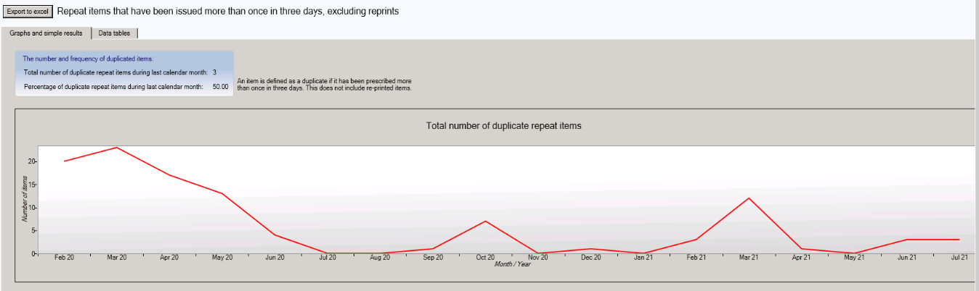

***Simple results***

The blue text box shows the total number of duplicate repeat items during the latest full calendar month, and what percentage this represents of the total number of repeat items issued. The search does not include items generated using the reprint function within the clinical system – only duplicates/re-issued items.

Note: An item is considered a duplicate if it is issued to a patient more than once in the last three days.

***Graph (shown above)***

The trend of the total number of duplicate repeat items prescribed over the last 18 calendar months.

***Data tables***

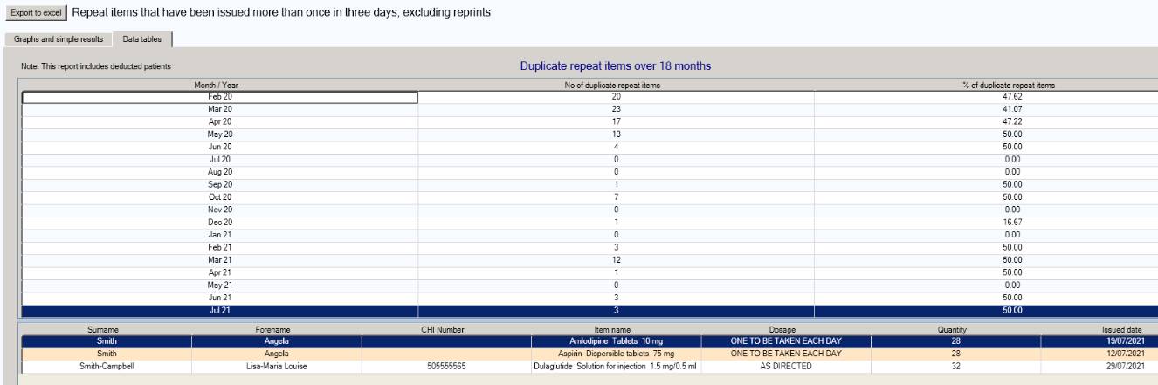

The ‘Data tables’ tab shows the number of duplicate active repeat items issued over the 18 calendar months, broken down by month, and what percentage the number represents of the total number of active repeat items issued in that month.

For example, in the table above, during June 2021 there were 3 duplicate active repeat items, which represented 50% of all active repeat items for that month.

The patient level detail displayed in the lower tier table defaults to the most recent full calendar month but previous months can be reviewed by selecting the relevant Month/Year.

Note: The patient detail table above shows the drill down of the individual patients and the duplicate items prescribed along with the date of duplication. The lists can be sorted by clicking on the relevant header (e.g. item name)

## Report: All repeats issued

**Patients who have had all repeats issued at the latest request**

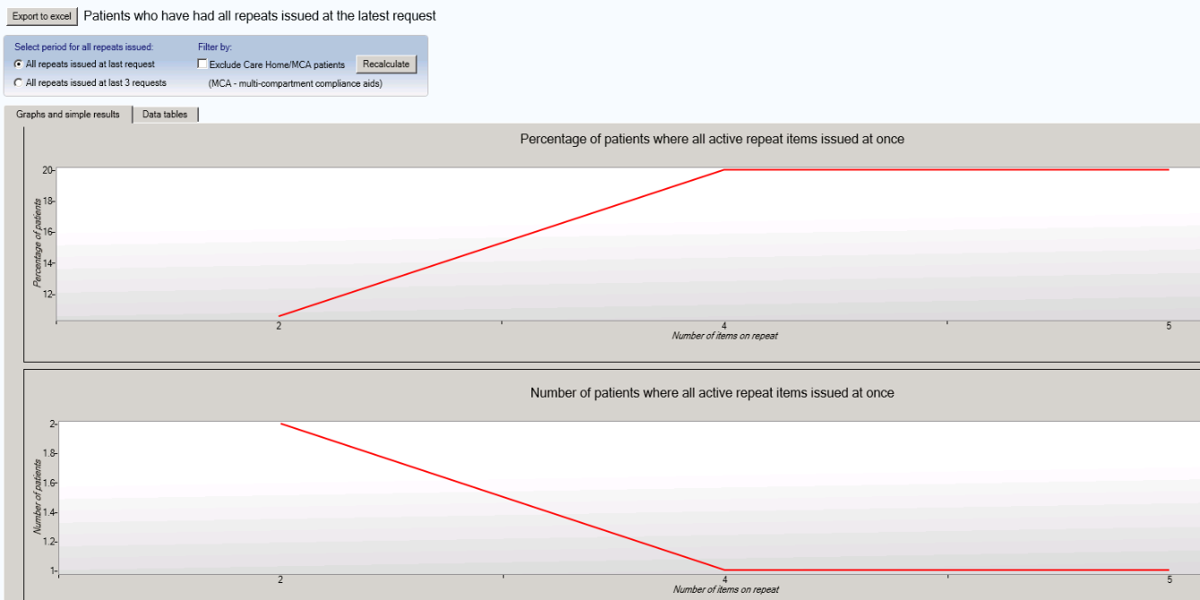

This report has a number of additional options which can be applied to the data and resulting charts. The report will display patients with all items issued at the latest request but also those with all items issued at the latest 3 requests.

The results can be filtered to exclude patients Read coded as being resident in a Care Home and those with Multi-compartment Compliance Aids.

***Graphs***

**Graph 1:** The percentage of patients with a specified number of active repeats who had all repeat items issued at once at the latest request (or latest 3 requests), compared to all patients with the specified number of active repeats. For example, in the graph above, 20% of patients with 5 active repeat items had all repeat items issued at once the last time they requested a repeat prescription.

**Graph 2:** The number of patients where all active repeat items were issued at once at the latest request (or latest 3 requests) grouped by the number of items on the request. For example, in the graph above, 1 patient with 4 active repeat items ordered them all at once the last time they requested a repeat prescription.

***Data tables***

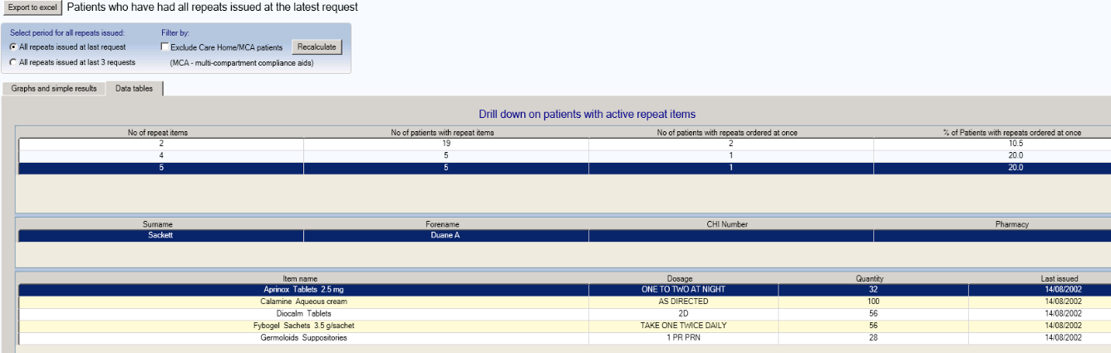

The ‘Data tables’ tab lists the number of active repeat items patients are on, excluding those with only one active repeat.

It also shows how many patients are on the selected number of active repeat items and how many of those patients had all of their items issued at once the last time, or last 3 times, a repeat prescription was requested.

For example, in the table above, there are 5 patients with 5 active repeat items, of which 1 (20%) had all of their items issued at once the last time a repeat prescription was issued.

By right clicking on the patient, you can use view items issued matrix to review issue patterns over the preceding 12 months.



Note: The above screenshot shows the drill down of the individual patient’s names, and the repeat items prescribed for the selected patient.

## Report: Repeats not issued

**Active repeats that have not been issued in given time periods with British National Formulary (BNF) chapter drill down**

Select a BNF chapter to filter results.

Select the required time period over which items were not issued.

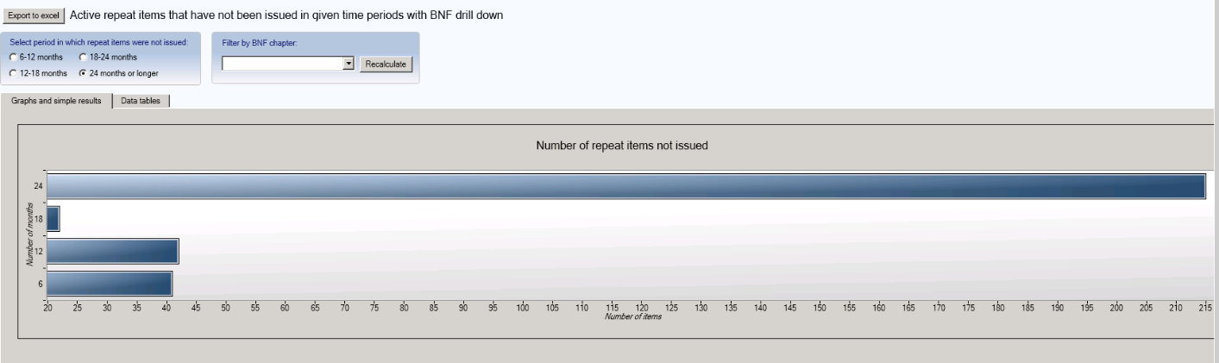

***Graph***

The bar chart shows the total number of active repeat items that have not been issued for the last 6-12 months, 12-18 months, 18-24 months, and 24+ months.

For example, in the above graph, there were 215 active repeat items not requested during the last 24 months or longer.

Hovering over the bar chart will allow visualisation of the exact number of items within each time period.

***Data tables***

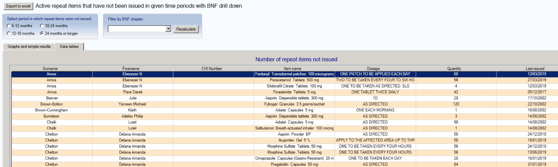

The ‘Data tables’ tab lists the non-issued active repeat items for the selected period, it also shows the date the item was last issued.

Note: The data table default period in which active repeat items were not issued is 18-24 months. To change this click on the relevant radio button and the data table will automatically refresh.

You can sort the data by item name for easy initial review. Click on “item name” at the top of the table to sort the items alphabetically.

For more comprehensive review, you can also filter the data by BNF chapter. Simply click on the drop down arrow , select the relevant chapter and then click on Recalculate.

## Report: Priority patients

**Multi-compartment compliance aids/Resident in a care home**

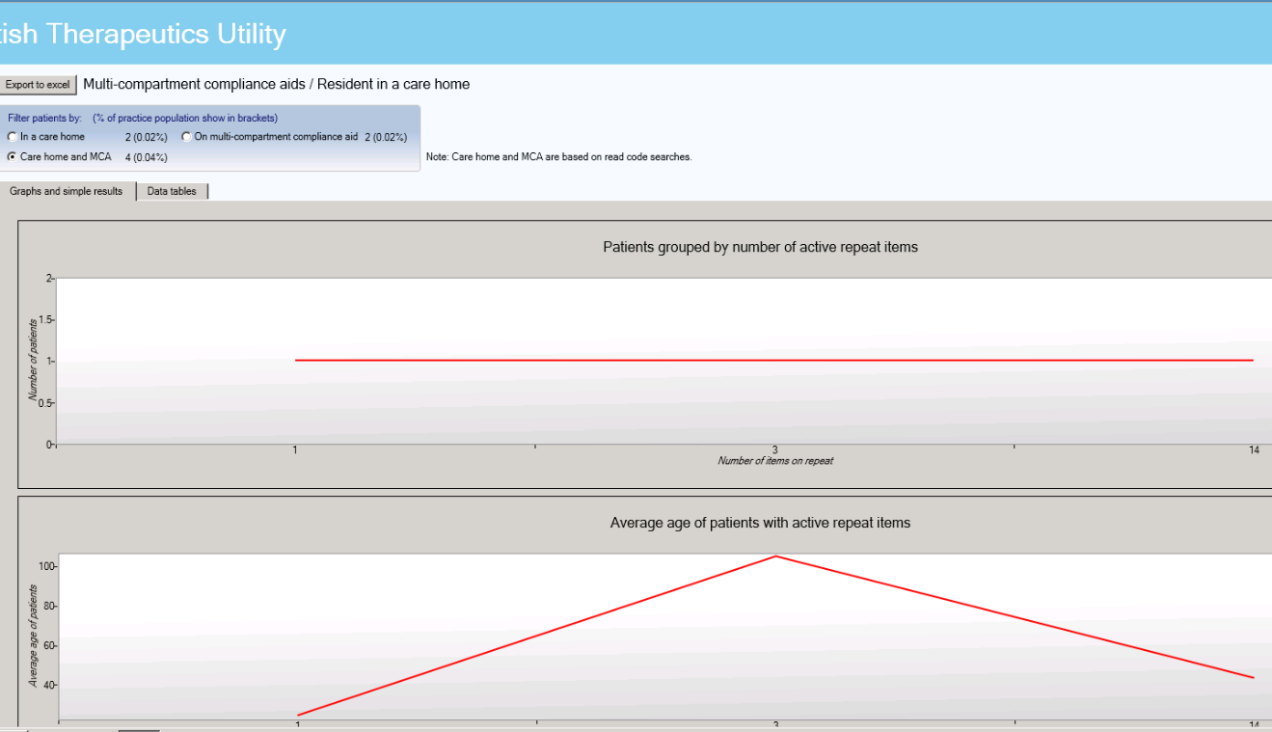

Select the group of patients you wish to filter results by.

***Simple results***

The results display the number of patients Read coded as being resident in a care home, and/or Read coded as having medication dispensed in a multi-compartment compliance aid, and the total combined number of patients. The percentage of the practice population this represents is shown in brackets.

***Graphs***

By selecting the desired patient group using the radio button the graphs will display the following:

**Graph 1:** The number of patients with a specified number of active repeat items, for the selected group of patients.

**Graph 2:** The average age of patients with a specified number of active repeat items, for the selected group of patients.

It should be noted that this information is reliant on Read coding within your clinical system. MCA (8BIA.) and Care home (13FX. – 13F6. – 13F61 – 13FK. – 13F72 – 13FT. – 13F7. – 13FK.) ***Data tables***

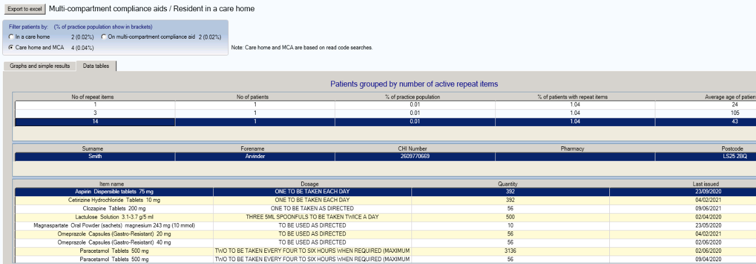

The ‘Data tables’ tab lists the number of active repeat items the selected group of patients are on.

It also shows how many patients are on the selected number of active repeat items and what percentage this represents of both the practice population and of the total number of patients with active repeat items.

Finally, it shows the average age of patients with the selected number of active repeat items.

For example, in the above table, there is 1 patient who have 14 active repeat items, representing 0.01% of the practice population and 1.04% of all patients with active repeat items. The average age of patients with 8 active repeat items is 43 years.

Note: The tables above shows the drill down of the individual patients’ names, and details of the repeat items prescribed for the selected patient.

The default patient group shown is ‘All Care Home and MCA’. To select a specific patient group, click on the relevant radio button and the tables will take a few moments to refresh.

## Report: CMS

**CMS – Serial Prescribing**

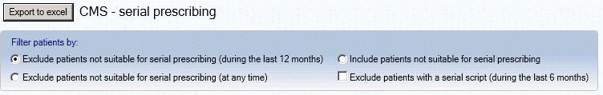

Select the group of patients you wish to filter results by.

***Simple results***

The results display (graphically) the patients who are registered for the Chronic Medication Service. There is the option to filter by patients marked as suitable or not suitable for serial prescribing. When choosing to exclude patients not suitable for serial prescribing it is possible to either exclude those patients marked not suitable within the previous 12 months or those patients marked at any point in time. Patients who have received a serial script during the last 6 months can also be excluded.

***Graphs***

By selecting the desired patient group using the radio button the graphs will display the following:

**Graph 1:** The number of patients with a specified number of active repeat items, for the selected group of patients.

**Graph 2:** The average age of patients with a specified number of active repeat items, for the selected group of patients.

***Data tables***

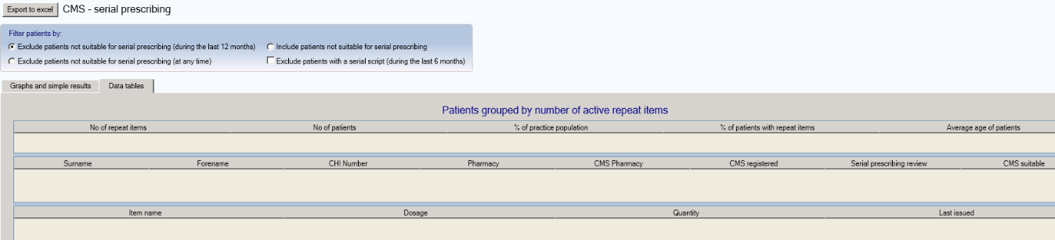

*NB Data not available for screenshot for this report*

The ‘Data tables’ tab lists the number of active repeat items the selected group of patients are on.

It also shows how many patients are on the selected number of active repeat items and what percentage this represents of both the practice population and of the total number of patients with active repeat items.

Finally, it shows the average age of patients with the selected number of active repeat items.

In addition to patient identifier information the patient detail window also shows:

* The pharmacy entered by the practice as the patients’ preferred pharmacy and the CMS registered pharmacy
* The date of the most recent serial prescribing review
* CMS suitability status

Note: Click on the number of repeat items then a patient name to drill down to patient drug level. An (s) preceding the item name indicates that it is a serial prescription.

## Report: Effective Feedback to Improve Primary Care Prescribing Safety (EFIPPS)

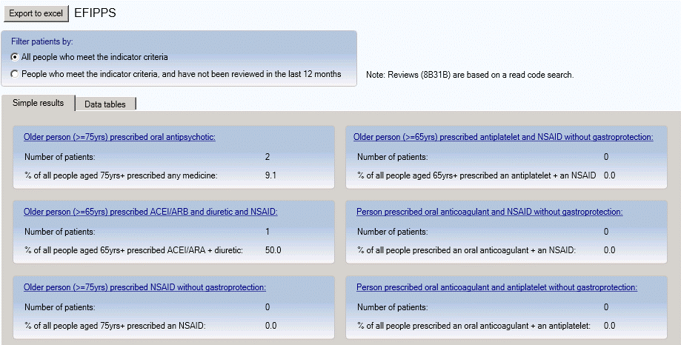

Click on indicator name to access patient level data.

Excludes patients coded with Polypharmacy Medication Review (8B31B).

***Simple results***

The dashboard shows a summary of the number of patients identified for each of the EFIPPS indicators with the percentage these patients represent against a specific practice subset. Users can click on the hyperlinks for each medicine indicator to view information about the specific medicines included in each class. By clicking on the radio buttons users can filter the lists to exclude patients already coded for a Polypharmacy Medication Review (8B31B).

***Data Tables***

Users can either click on the indicator names to access patient level information for that particular indicator or click on the ‘Data tables’ tab.

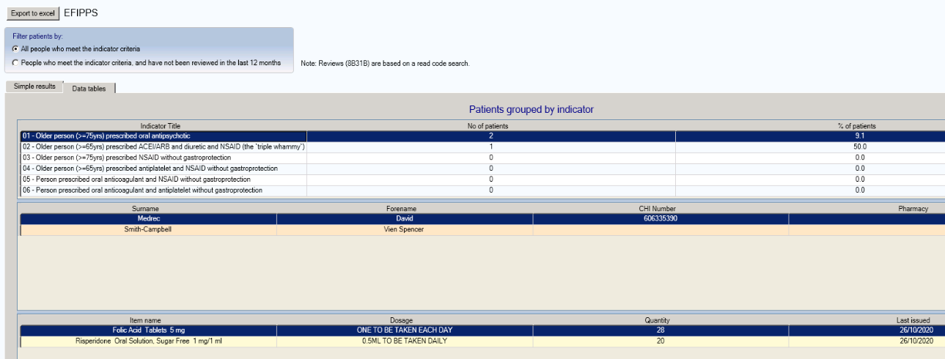

The top section of the dashboard lists all of the EFIPPS indicators with summary figures. Users can then click on the required indicator to drill down into patient specific information and also view each patient’s active repeats and any acutes issued in the last 84 days. Acute items are identified by “(a)” proceeding the drug name.

## Report: Respiratory

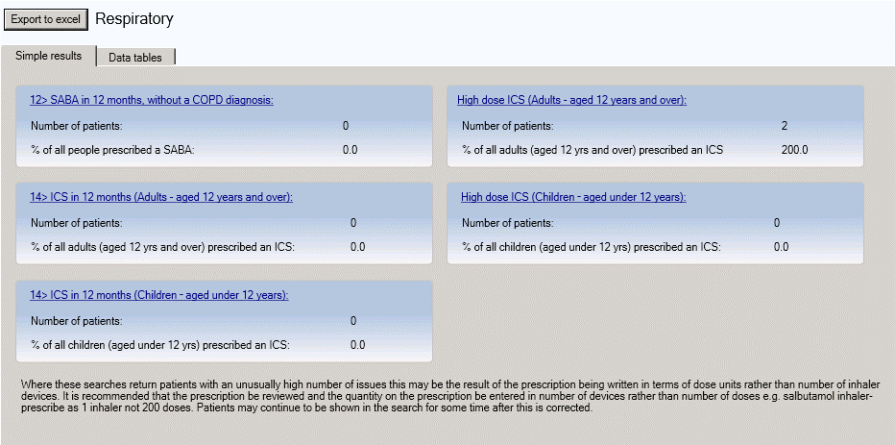

Click on indicator name to access patient level data.

***Simple results***

The Simple results dashboard shows a summary of the number of patients identified for each of the respiratory indicators with the percentage these patients represent against a specific practice subset. Clicking on the hyperlink for each indicator will display the data table for that indicator.

***Data Tables***

Users can either click on the indicator names (in Simple results) to access patient level information for that particular indicator or click on the ‘Data tables’ tab.

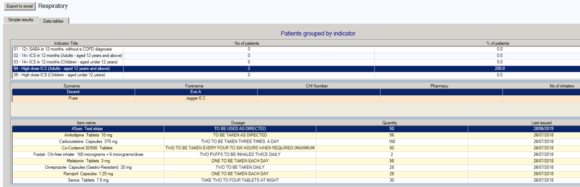

The top section of the dashboard lists all of the respiratory indicators with summary figures. Users can then click on the required indicator to drill down into patient specific information and, by selecting a specific patient, can also view each patient’s active repeats and any acutes issued in the last 84 days. Acute prescriptions are annotated with (a). The data can be sorted by any of the columns by clicking on the column heading.

Where an unusually high number of issues appears within the report results

Where these searches return patients with an unusually high number of issues this maybe the result of the prescription being written in terms of dose units rather than number of inhaler devices. It is recommended that the prescription be reviewed and the quality on the prescription be entered in number of devices rather than number of doses e.g. salbutamol inhaler – prescribe as 1 inhaler, not 200 doses. Patients may continue to be shown in the search for some time after this is corrected.

## Report: Chronic Pain

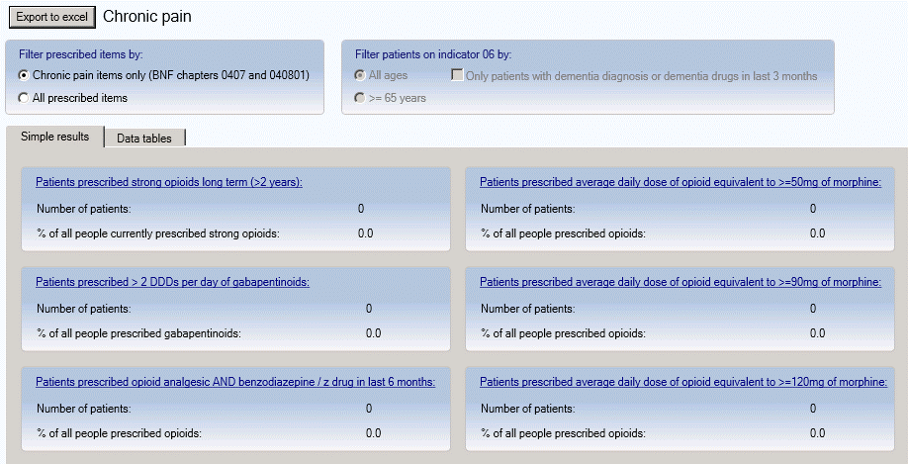

Click to filter **opioid and benzo/z drug search** by age and/or dementia (dementia coding or dementia drugs within 3 months).

Click to filter by BNF chapters 0407 & 040801 only or all items.

Click on indicator name to access patient level data.

***Simple results***

The dashboard shows a summary of the number of patients identified for each of the chronic pain indicators with the percentage these patients represent against a specific practice subset. Users can click on the hyperlink for each indicator to move to the data table for that indicator.

***Data Tables***

Users can either click on the indicator names to access patient level information for that particular indicator or click on the ‘Data tables’ tab.

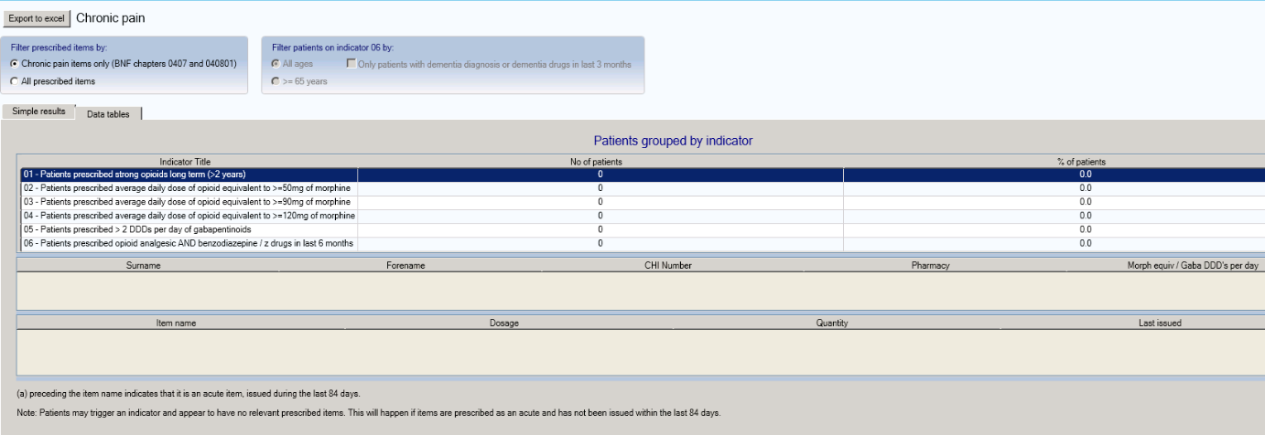

The top section of the dashboard lists all of the chronic pain indicators with summary figures. Users can then click on the required indicator to drill down into patient specific information and, by selecting a specific patient, can also view each patient’s active repeats and any acutes issued in the last 84 days. Acute prescriptions are annotated with (a).

The radio buttons at the top of the report can be used to display either chronic pain medicines only (BNF sections 0407 and 040801), or all prescribed items. Indicator 06 (opioid analgesic and benzodiazepine / z drug) can be filtered by age (>=65 or all ages) and / or dementia diagnosis (readcoded dementia or having received a dementia drug within the previous 3 months).

The data can be sorted by any of the columns by clicking on the column heading.

Note: Patients may trigger an indicator and appear to have no relevant prescribed items. This will happen if items are prescribed as an acute and have not been issued within the past 84 days.

## Report: Antidepressants, benzodiazepines and z-drugs

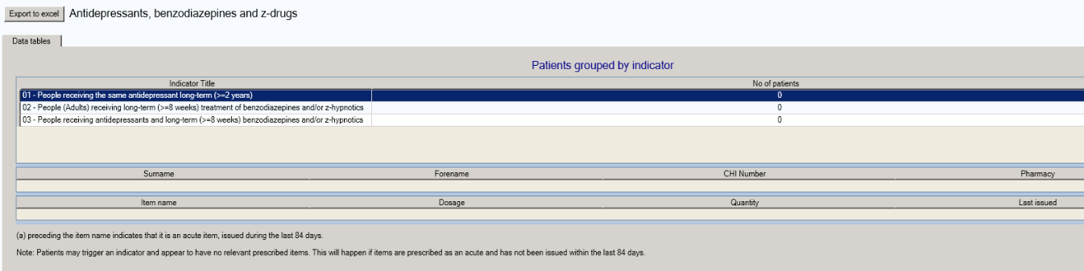

There is only a **Data tables** tab for Antidepressants, Benzodiazepines and Z-Drugs.

Users can click on the required indicator to drill down into patient specific information and, by selecting a specific patient, can also view each patient’s active repeats and any acutes issued in the last 84 days. Acute prescriptions are annotated with (a).

The data can be sorted by any of the columns by clicking on the column heading.

Note: Patients may trigger an indicator and appear to have no relevant prescribed items. This will happen if items are prescribed as an acute and have not been issued within the past 84 days.

## Report: Diabetes

There is only a **Data tables** tab for Diabetes.

The top section lists all of the diabetes indicators with summary figures.

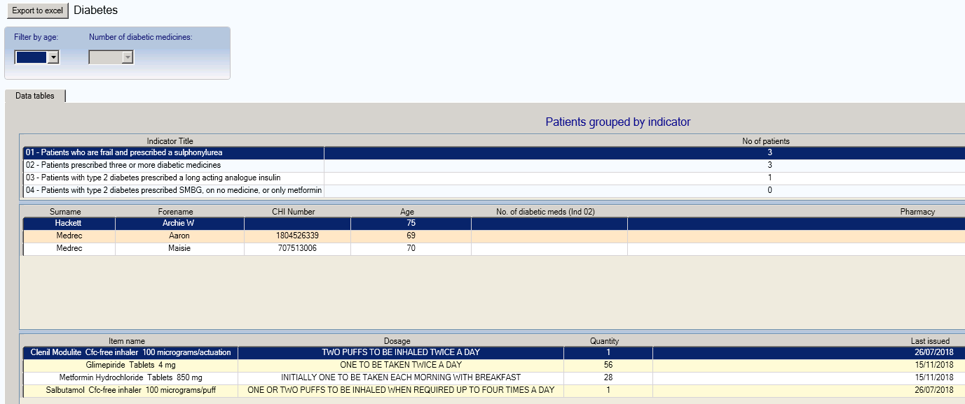

The report has two filters that can be applied:

1. Patient age bands can be filtered to 55+, 65+, 75+, 85+
2. Number of diabetic medicines can be filtered to prioritise patients on a higher number of diabetic medications.

Users can then click on the required indicator to drill down into patient specific information and, by selecting a specific patient, can also view each patient’s active repeats and any acutes issued in the last 84 days. Acute prescriptions are annotated with (a). The data can be sorted by any of the columns by clicking on the column heading.

## Report: Polypharmacy

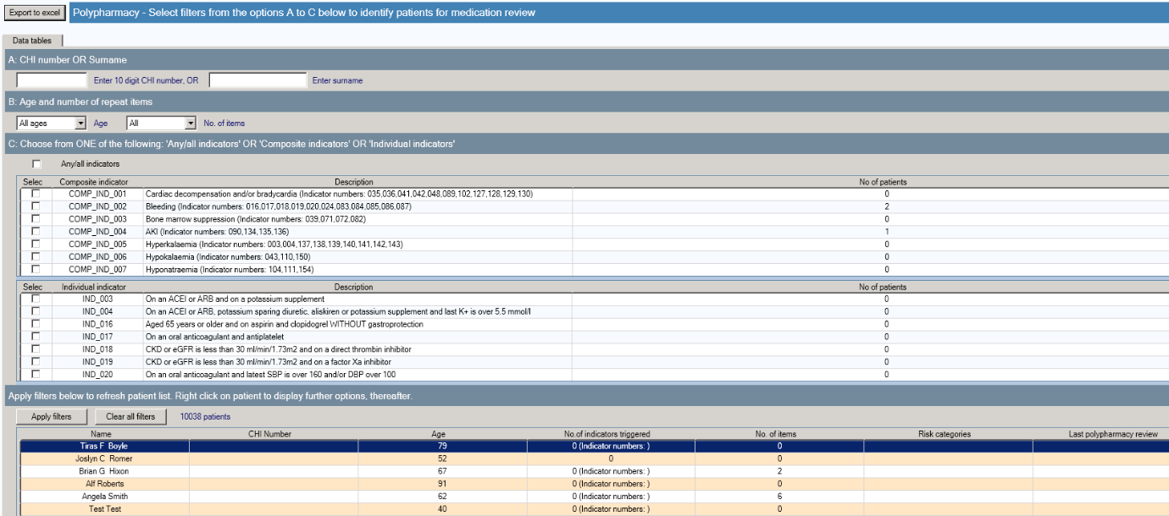

There is only a **Data tables** tab for Polypharmacy.

***Patient selection***

There are three methods of searching for and filtering patients for medication review:

**A – CHI number or Surname:** Users can enter either a patient’s CHI number or their surname to find specific patients.

**B – Age and/or number of repeat items:** The default for all of these options is to include all options. From the drop down menus users can select a specific age range and/or a specific number of repeat items.

Sections A and B can be used in combination to filter patients that trigger any/all indicators.

**C – Composite and individual indicators:** Users can click on the ‘Any/all indicators’ radio button to include all indicators.

OR

Users can select one or more of the composite indicators. If a composite indicator is selected, it is not then possible to also select an individual indicator.

OR

Users can select one or more of the individual indicator(s). If an individual indicator is selected, it is not then possible to also select a composite indicator.

Sections B and C can be used in combination to filter patients.

When the required filters have been selected users should click on the ‘Apply filters’ button to display a list of patient(s) that have triggered the report. Users can click on the ‘Clear all filters’ button will clear all selections made in sections A to C.

Each time a filter is changed in section A, B or C e.g. changing the age range the ‘Apply filters’ button should be clicked to refresh the list of patients.

***Data tables***

When the required filters have been applied the next section of the report lists all patients that have triggered the report. For each patient, details are shown about the number of individual indictors triggered (specifying which indicators) the number of repeat prescription items, the clinical risk categories and the date of the last polypharmacy medication review.

As per the national [*Polypharmacy Guidance Realistic Prescribing, 3rd Edition, 2018*](http://www.therapeutics.scot.nhs.uk/wp-content/uploads/2018/04/Polypharmacy-Guidance-2018.pdf), the read code that is used for polypharmacy medication review is:

**8B31B - Polypharmacy medication review**

As with other reports in STU the data in this table can be sorted by any of the columns by clicking on the column heading.

By selecting a specific patient, can also view each patient’s active repeats and acutes issued in the last 84 days. Acute prescriptions are annotated with (a).

## Report: Clinical safety checks

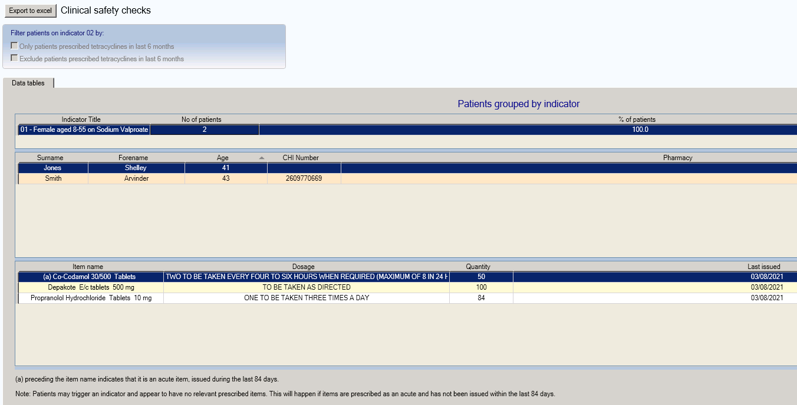

There is only a **Data tables** tab for Clinical safety checks.

***Data tables***

Users can click on the required indicator to drill down into patient specific information and, by selecting a specific patient, can also view each patient’s active repeats and any acutes issued in the last 84 days. Acute prescriptions are annotated with (a). The data can be sorted by any of the columns by clicking on the column heading.

As with other reports in STU the data in this table can be sorted by any of the columns by clicking on the column heading.

By selecting a specific patient, can also view each patient’s active repeats and acutes issued in the last 84 days. Acute prescriptions are annotated with (a).

Note: Patients may trigger an indicator and appear to have no relevant prescribed items. This will happen if items are prescribed as an acute and have not been issued within the past 84 days.

## EScro Data Pump

**Note:** This information is largely aimed at users making technical changes to the practice’s IT setup. Further information can be found by viewing the install guide at [www.escro.co.uk](http://www.escro.co.uk/)

The Scottish Therapeutics Utility runs against a reporting database created by the EScro Data Pump. The Data Pump creates a small high speed reporting database which extracts the information from the clinical system. This in turn allows STU to run against the data without having any impact on the clinical system itself and other users.

The Data Pump is usually installed on the GPC machine for Vision users, or on the server for EMIS users. It normally runs overnight on a scheduled task, ensuring that the data is refreshed daily. If the Data Pump is not on a scheduled task, it can be run manually by doing the following:

**Vision users –** go to the GPC machine, look on the desktop for the ‘EScro snapshot’ icon, double click and leave to run and close automatically.

**EMIS users –** go to the server, look for the ‘EScro EMIS Data Pump’ icon, double click to open, and then click on ‘Run’ and leave to run and close automatically.

You can use **Help | About** on the STU application to check the Data Pump and database details. ‘About’ information shows the name of the server and reporting database that STU runs against. It also shows when the Data Pump last ran, and which version is installed.

