
GMS Prescribing 2016 – Guidance for Boards
Therapeutics Branch February 2016
Version 1.0

Introduction

Prescribing is the most common patient-level intervention in the NHS. Within primary care in NHS Scotland, 101m prescription items were dispensed in 2014/15 at a cost of £1bn. This equates to the average GP prescribing around 77 medicines per working day.

The GP appraisal & revalidation process identifies prescribing as crucial, and states that:

‘You are required to provide evidence that your prescribing is effective and efficient, that you reflect on the different types of information available to you concerning prescribing, and make appropriate changes.’

Good prescribing has been defined as:
- Safe (avoidance of high risk unless clearly justified)
- Effective (evidence that the drug works)
- Necessary (the patient benefits from treatment)
- Most cost effective choice (all other factors being equal, choose the cheapest)
- Following recognised peer guidance (formularies or other consensus statements)

This framework has been produced by the Therapeutics Branch for Health Boards, Prescribing Support Units and GP practices to support the prescribing element of the interim 2016/17 GMS contract.

The Quality Improvement Approach (appendix 1) and Practice Specific Prescribing Action Plan (appendix 2) are tools which may be useful to Boards in delivering prescribing improvement in 2016/17. The framework is intended as guidance only and should not be considered as mandatory.

History

Prescribing has retained prominence in GMS contract since 2003, through the inclusion of Medicines Management within Quality and Outcomes Framework (QOF). This has been supplemented through the Quality & Productivity Prescribing in 2011 and the Scottish Quality Prescribing Initiative in 2013.

In December 2015 the Therapeutics Branch published a Review of GMS Medicines Management Domain which concluded that a contractual focus on prescribing has demonstrated continued improvement in the cost-effectiveness and quality of prescribing in primary care in NHS Scotland.

Change for 2016/17

In late 2015 the Cabinet Secretary for Health, Wellbeing and Sport announced that the QOF would be dismantled before the beginning of the 2016/17 contract. An interim arrangement will be in place for 12 months with a new contract framework in place for 2017/18.

In December 2015 the interim arrangements were announced. Quality Prescribing remains a key priority for NHS Scotland and this is reflected in its inclusion the interim arrangements.

The contract notes that GP practices:

‘Will continue to work with the NHS Board prescribing advisors and prescribing support pharmacists, where available, to agree appropriate actions related to prescribing and seek to evidence change’

Principles for prescribing improvement

There are a number of aspects which may be considered when developing a strategy for supporting primary care prescribing in 2016/17.

The narrative of the interim arrangements considers a move from a focus on process, to a Quality Improvement approach. As such, familiarity with the Quality Improvement Journey is highly valuable. Appendix 1 describes how the QI Journey can be applied in a prescribing context.

Quality Improvement is at the heart of delivering a safer, more effective and person centred NHS in Scotland. This guidance aligns with the Quality Improvement Journey which can be used as a framework to support this area of the contract.

In the 2016/17 contract, the prescribing element evolves from a mandatory specified approach, towards ongoing work with prescribing support teams. The use of a practice specific prescribing support plan may be considered to provide evidence of the journey using qualitative and quantitative outcomes. Appendix 2 contains a suggested framework for this.

This document and its appendices are intended as a guide for implementation and should be applied on a local basis in conjunction with local arrangements.
Appendix 1
Quality Improvement Approach as a principle for prescribing in the 16/17 GMS contract arrangements

This document contains the stages of the Improvement Journey described by the QI Hub. The stages have been condensed to complement the practice specific prescribing action plan in appendix 2. The two documents should be considered together.

Stage | Background
Stage 1  Discover | This stage is about identifying the areas of medicines use or prescribing you wish to improve.  There are a number of nationally driven prescribing priorities that can be considered, including:  - National guidance on Polypharmacy, Respiratory and Diabetes  - National Therapeutics Indicators  - Scottish Therapeutics Utility  - Scottish Reduction in Anti-Microbial Prescribing Strategy  These should be considered alongside NHS Board, Health and Social Care Partnership, and practice priorities.  This should help determine the priority areas for improvement. That could be covered during the ‘Prescribing Action Plan Development session’ and listed as shown below:  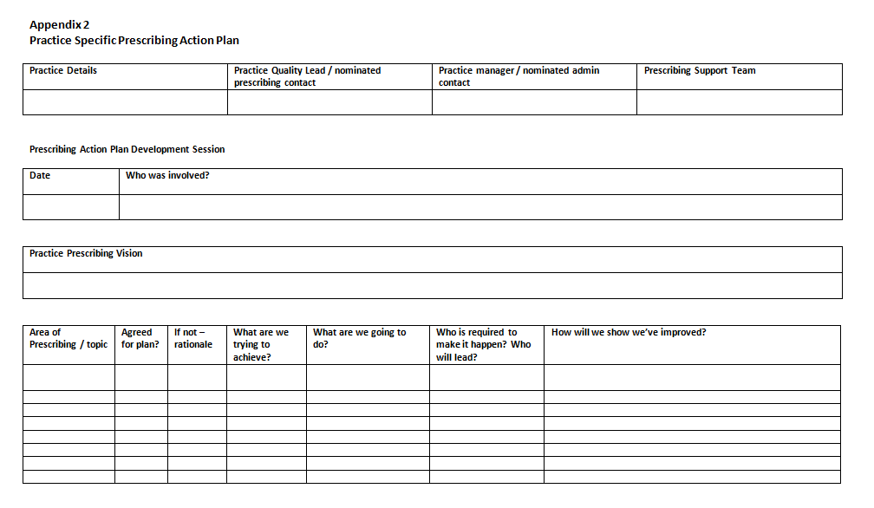  Remember:  - Health Board Prescribing Support Teams can provide prescribing information from PRISMS to help set context and generate ideas  - When considering areas for improvement it is important to be clear on what is expected to be achieved  - Make sure all prescribers are bought into the improvement  - Clarify why this piece of work is being considered in terms of benefits to patients and ensuring that it is a safe, effective and person centred approach
Stage 2  Explore | This stage of the journey allows you to investigate in more detail areas being considered for change.  An important aspect of quality improvement is ensuring the improvement will be measured. This may take the form of prescribing analysis, quantitative and/or qualitative measures, for example from prescribing data.  This would be recorded in the Prescribing Action Plan as shown below:  Remember:  - This is a good point to find supporting resources, such as materials on the evidence base and implementation tools  - Early adopters will have useful guidance and learning, whether they immediately succeeded in their change or are still working on it
Stage 3  Design & Refine | This stage allows you to review your ideas for improving the areas of prescribing and plan for delivery.  Board Prescribing Support Teams often produce support materials to help facilitate improvement. This includes:  - Prescribing bulletins  - Therapy review materials  - Implementation guides  These can be used by a wide range of practitioners to aid in the implementation and should be incorporated into plans.  This can be recorded on the Prescribing Plan as shown below:  Remember:  - Even the most robustly developed resources may not be fit for every purpose or situation. Small tests of change allow for these to be refined  - Some practices may benefit from an entirely bespoke approach  - Focussing on how the resources contribute to the goal helps ensure the best use of time and effort
Stage 4  Introduce | This stage is where the change happens.  Deliver your improvement according to the planning designed above. It is vital to make sure that it is clear who will lead on a piece of work.  This can be recorded on the Prescribing Plan as shown below:  Remember:  - Patients, as the most important stakeholders, should be well informed about the change  - Patients are becoming increasingly engaged on new prescribing approaches, via both modern and traditional routes  - Board Prescribing Support Teams work with community pharmacy colleagues around changes. They can follow up as the improvement is made
Stage 5  Spread | This stage is about communicating with your stakeholders and sharing your learning  It is important to make others are of the benefits and challenges of your improvement.  Remember:  - Local prescribing meetings are an ideal practice to support this part of the improvement journey  - Consider how to engage with other stakeholders, such as patients and community pharmacy  - To share best practice and success

Appendix 2
Practice Specific Prescribing Action Plan

Practice Details | Practice Quality Lead / nominated prescribing contact | Practice manager / nominated admin contact | Prescribing Support Team

Prescribing Action Plan Development Session
Date | Who was involved?

Practice Prescribing Vision

Area of Prescribing / topic | Agreed for plan? | If not – rationale | What are we trying to achieve? | What are we going to do? | Who is required to make it happen? Who will lead? | How will we show we’ve improved?

Mid Year Update
Area of prescribing | Progress update | Mid-year measure / score | Next step

End of year Update
Area of prescribing | Progress update | Final measure / score | Reflections | Moving forward (completed / carry forward / no longer required)

Reflections of progress towards prescribing vision

http://www.appraisal.nes.scot.nhs.uk/i-want-access-to/toolkits/scottish-gp-appraisal-toolkit/domain-2/qia/prescribing.aspx
http://bma.org.uk/working-for-change/negotiating-for-the-profession/bma-general-practitioners-committee/gpc-members/scottish-general-practitioners-committee/gms-contract-changes-in-scotland

